**Table of Content**

**Chapter 1 HTML**

**Chapter 2 CSS**

**CHAPTER 1**

**INTRODUCTION TO HTML**

**1.1 Introduction to HTML**

What is Internet?

* The largest network of networks in the world,
  + joining many government, university and private computers together
  + providing an infrastructure for the use of E-mail, bulletin boards, file archives, hypertext documents, databases and other computational resources
* The vast collection of computer networks which form and act as a single huge network for transport of data and messages across distances which can be anywhere from the same office to anywhere in the world.

Brief History of Internet

* Internet born in 1969 - called ARPANET (**Advanced Research Projects Agency Network) Department of Defense in US.**
* 1969 ARPANET was connection of computers at UCLA (**University of California, Los Angeles)**, Stanford Research Institute, UCSB (**University of California, Santa Barbara)**, and the University of Utah
* 1970’s – proposed TCP architecture by Vint Cerf & Bob Kahn at Stanford
* 1973 - File Transfer Protocol (FTP) established
* 1977 - University Wisconsin has first “large” Email system 100 users
* 1984 - Domain Name Server introduced
  + allows naming of hosts, no longer numeric
* 1991 - Tim Berners-Lee releases World Wide Web!
* 1998 - Mosaic (becomes Netscape) designed by graduate students at University of Illinois
  + first point-and-click browser
* Today, the Internet is a public, cooperative, and self-sustaining facility accessible to hundreds of millions of people worldwide.

Protocol

* A **protocol** is a set of rules for exchanging messages between machines connected over a network.
* 1970 - the initial ARPANET host-to-host protocol, (Network Control Protocol -NCP)
  + Not suitable for running over multiple networks.
* 1974 - TCP/IP (Transmission Control Protocol /Internet Protocol)
  + Enables two hosts to establish a connection and exchange streams of data.
* Lots of different protocols existed:
  + FTP, Telnet, NNTP (**Network News Transfer Protocol)**, WAIS (Wide Area Information Server), SMTP (**Simple Mail Transfer Protocol)**

World Wide Web

* The World Wide Web is a way of accessing information over the medium of Internet.
* WWW is also known as the web.
* Communication on the web happens through HTTP.
* Web information is stored in Web pages
* Web Pages are stored on Web servers
* Web clients view the pages in a Web browser.
* Popular browsers are Internet Explorer and Netscape Navigator

Introduction to HTML

* HTML was invented in 1991 by Tim Berners-Lee.
* HTML
  + stands for Hyper Text Markup Language
  + It is used to design and develop Web Pages.
  + It is a plain **TEXT** file, which usually has a **.htm** or **.html** suffix
  + It can be created using a simple word processor or editor (such as, Notepad).
  + It includes text, images, audio, video, applications (applets, server-side code), and other additional gadgets (Flash, VRML, Shockwave, IPIX etc.).
  + It can contain Hyperlinks, which can redirect the user to other resources available on the net.
* HTML
  + Browser/Platform Independent
  + Not Case Sensitive
    - <FONT>, <Font> and <font> are all equivalent.
  + Different from other Programming Languages
    - So, it has no variable, function
* Comments in HTML

<! -- This is a comment -->

* With HTML, White Space is Preserved

URL – Uniform Resource Locator

* Identifying documents on the Internet:
  + The (unique) Identifier of a document is the URL (Uniform Resource Locator).
  + This is the information we usually enter in the browser’s Address Bar when we want to see a specific Web page.
* The DNS uses the URL to find the IP.

protocol

file path

Port No.

Host name (translates to IP address)

HTTP://www.sela.co.il:8080/home.html

HTML tags and attributes

* The HTML instructions are called tags, and look like
  + **<tag> ….. Text here…….. </tag>**
* Container tags: Tags that have starting as well as ending part.
  + **e.g. <title>Title of the Web Page </title>**
* Empty tags: Tags that do not have the closing part.
  + **e.g. <br> , <hr>**
* (HTML instructions + text to which the instructions apply)= HTML elements
* An attribute is an additional feature you can use to configure the element
* Attributes are optional.

HTML Document Structure

**<html>**

**<head><! - - Head Session - - >**

**<title>Title of the Web Page</title>**

**</head>**

**<body><! - - Body Session - - >**

**<! - - Contents on the Web Page - - >**

**</body>**

**</html>**

**Note: It has two sessions, head and body or frameset sessions.**

<**frameset>**

**<! – here are all of your frame definition -- >**

**</frameset>**

**<html>**

**<head>**

**Here is your head session.**

**</head>**

**<body>**

**And there is your page content**

**</body>**

**</html>**

***Note: Assign Page***

**<html>**

**<head>**

**Here is your head session.**

**</head>**

**<frameset>**

**And there is your page content**

**</frameset>**

**</html>**

***Note: Several pages within frames***

Head Session

* Enclosing in <head></head> tag
* The following tags can be added to the head section:<base>, <link>, <meta>, <script>, <style> and <title>
* Tags that can go in the document head.
  + <title> Indicates the title of the document that is used as the window caption, It is only valid in the head section.

<title> Title Sample!!! </title>

* + <base> specifies the relationship between the current document and other documents
  + <meta> element can be used to specify name/value pairs describing various properties of the document.

Body Session

* Enclosed in <body></body>
* Some important attributes of the BODY tag
  + bgcolor = "color" (or) "#rrggbb"
  + bgproperties = FIXED
  + background = "url of the image"
  + text = "color" (or) "#rrggbb"
  + link = "color" (or) "#rrggbb"
  + alink = "color" (or) "#rrggbb"
  + vlink = "color" (or) "#rrggbb"
* The body tag allows for the specification of colors to mark links within a page
  + link – specifies the default color of unvisited links in the document.
  + vlink – specifies the color of the visited links in the document.
  + alink – specifies the color of an active link in a document (a link is active when it is clicked).

For example <body link="BLUE" alink="CYAN" vlink="YELLOW">

* In this example, links will be colored blue, When they are clicked, they will change to cyan, from that point (one they have been clicked), they will be colored yellow.

|  |  |
| --- | --- |
| Value | Description |
| color_name | Specifies the link color with a color name (like "RED"). |
| hex_number | Specifies the link color with a hex code (like "#ff0000") |
| rgb_number | Specifies the link color with an RGB code (like rgb(255,0,0)) |

* background = x.jpg **E.g.<body background = "bg_star1.jpg">**
  + Specifies an image to be filled as background.
* bgcolor = color **E.g. <body bgcolor = "BLUE">**
  + Specifies the background color
* bgproperties = FIXED
  + Fixes the background image so that it doesn't scroll
* rightmargin/leftmargin = n
  + Specifies the left/right margin for the entire page
* text = color
  + Specifies the color of text in the page
* topmargin/bottommargin = n
  + Specifies the top/ bottom for the entire page.

First Web Page

* Type the following code in you favorite editor (notepad/textpad/wordpad/editplus) file.

<html>

<head><title>My first HTML page</title></head>

<body>

WELCOME TO HTML!!!!!

</body>

</html>

* Save this file with the name "LearningHTML.htm/html".
* Open this document in the browser.

Formatting – Headlines

* Header Tags
  + HTML has six levels of headings, numbered 1 through 6 and 1 being the largest.
  + Display in larger and bolder fonts.
  + HTML automatically adds an extra blank line before and after a heading.
* The font size of the heading will go on decreasing from "h1 to h6".
* For example

<html>

<body>

This is normalizing size text.

<h1> This is largest headline. </h1>

<h3> This is the size of headline H3 </h3>

<h5> While this is H5</h5>

</body>

</html>

Text Formatting Tags

**Paragraphs**

* <p></p> - used to create new paragraphs.
* Main attributes:
  + ID – Labels the element with a unique identifier.
  + ALIGN – Aligns the paragraph content to the left, right, center or justified. The default is "left align".

**Line Breaks**

* <br> - to insert returns or blank lines in the document.

For example: <p>This <br \> graph with line breaks </p>

**<div> Tags**

* The <div> tag defines a division or a section in an HTML document.
* The <div> tag is often used to group block-elements to format them with styles.
* Main attributes:
  + ID – Specifies a unique id for an element.
  + ALIGN – Align the paragraph content to the left, right or center. The default is "left align".
  + Class – Specifies a class-name for an element.

<**span> Tag**

* The <span> tag defines a division or a section in an HTML document.
* The HTML code for a paragraph demonstrating use of the STYLE attribute along with the span element.
* Main attributes:
  + ID – Specifies a unique id for an element.
  + Class – Specifies a class-name for an element.
  + Style(inline style) – Specifies an inline style for an element.

**Horizontal Lines**

* <hr> - used to draw a horizontal line across the web page.
* Main attributes:
  + SIZE – Set the line thickness (in pixels or percent).
  + WIDTH – Set the width of the line.
  + ALIGN – Set the alignment to LEFT, RIGHT or CENTER.
  + NOSHAPE – renders the bar without surrounding shadow. Turns line into 2D (two dimensional) rule instead of 3D (three dimensional) rule.

**<font> tag**

* Allows you to specify the font face and font size.
* Some common attributes are:
  + FACE – Specifies the font style.
  + SIZE – Specifies the font size. Value can range form 1 to 7. The default is 3. SIZE can be set as a relative value using + or –
  + COLOR – The color of a font can be specified using a hexadecimal number value six characters long.
  + Example :

<font FACE="Helvetica, Arial" SIZE="7" COLOR="#ff0000">

The Written Word!!!

</font>

Example:

<!DOCTYPE html>

<html>

<head>

<title></title>

</head>

<body>

<p>My mother has <span style="color:blue;font-weight:bold" ><font face="Verdana" size=7>blue</font></span> eyes and my father has <span style="color:darkolivegreen;font-weight:bold">dark green</span> eyes.</p>

</body>

</html>

**<pre> Tag**

* Different than other text formatting tags.
* ***Does not ignore spaces.***
* Can display data in tabular format using <pre></pre> tag.
* Too much cumbersome if frequent changes are required.
* Example:

<html>

<body>

<pre>

Let's make a Mark Sheet!!!

Serial Student ID Java Database FWT

1 1234 A B C

2 5645 B C A

3 6837 C B B

4 9874 D C C

</pre>

</body>

</html>

**Text Formatting Examples**

Example:

…

<p ID='LangArticle'> Language is not only made of words!

<p ALIGN=center> As surprising as it may sound, expressions, accent, culture and even manners are of no less importance than words

…

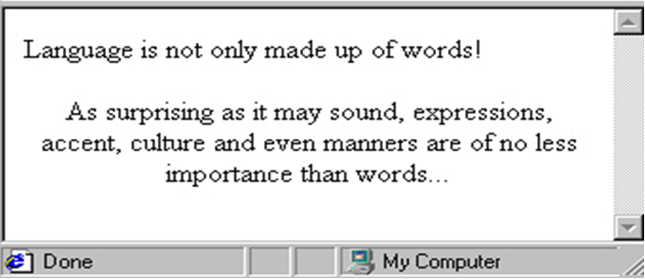

Example:

<span style="color:red">

<h3> This is a header. </h3>

<p> This is a paragraph. </p>

</span>

<div style="color:red">

<h3>This is a header. </h3>

<p>This is a paragraph. </p>

</div>

**Same Output**

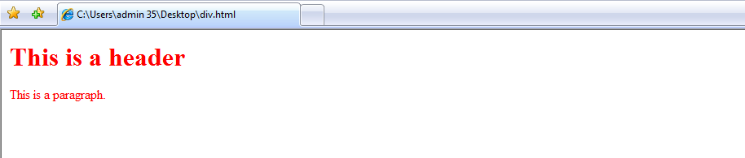

<BR> Tag

* Break the current line of text.
* Example:

...

By merging both the fantastic and the realistic, Gabriel Garcia Marquez <br> is able to turn his books a fascinating experience.

…

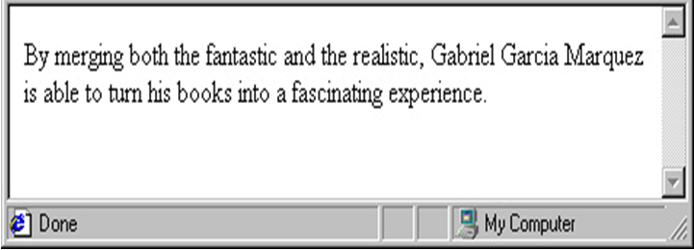

Example:

<font FACE="monospace"> This font is monospace. </font><br>

<font SIZE="+1"> This is the default font, its size is 4 </font><br>

<font SIZE="4" FACE="monospace"> This is monospace size 4! </font><br>

The following example is part of your editing sample:

<h2> The WindMills of Your Mind </h2>

<i> Noel Harrison </i>

<hr ALIGN=LEFT SIZE=4 WIDTH=310>

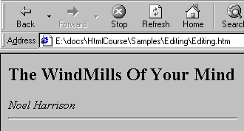

**Text Formatting Text**

|  |  |
| --- | --- |
| **Tag** | **Description** |
| <b>…</b> | Bold |
| <i>…</i> | Italic |
| <u>…</u> | Underline |
| <strike>…</strike> | Strike Through |
| <tt>…</tt> | Type writer (mono-spaced) |
| <center>…</center> | Centers the text on the screen |
| <sub>…</sub> | Subscript |
| <sup>…</sup> | Superscript |
| <big>…<big> | Bigger font(one font size bigger) |
| <small> …</small> | Small font(one font size smaller) |

**1.3 Symbols**

* Some characters are problematic for inclusions in an HTML file because:
  + They are hard to create with a text editor (e.g.©,® etc.).
  + They word as a component of HTML instructions (e.g. <, >, &).
* HTML supports two types of instructions for representing these characters.
  + **&charname**
    - e.g. ***&lt;***for "<" and ***&gt;***for ">"
  + **&#charcode**
    - e.g. ***&#038;***for "&", ***&#037;*** for "%", ***&#060;*** for "<"
* A partial table of special characters:

|  |  |  |  |
| --- | --- | --- | --- |
| **Char Code** | **Char Name** | **Symbol** | **Descriptions** |
| &#034; | &quot; | " | Quotation |
| &#174; | &reg; | ® | Registered Trademark |
| &#162; | &cent; | ¢ | Cent Sign |
| &#176; | &deg; | ° | Degree Sign |
| &#188; | &frac14; | ¼ | Fraction – Quarter |
| &#189; | &frac12; | ½ | Fraction – Half |
| &#190; | &frac34; | ¾ | Fraction – Three Quarters |
| &#160; | &nbsp; |  | Non Breaking Space |
| &#038; | &amp; | & | Ampersand |

**1.4 Lists**

* **Unordered Lists – Bullets appear**
  + <ul></ul> tag
  + <li> tag
  + TYPE attributes specifies the type of bullet(**disc_**Default and a filled circle, **circle_**An unfilled circle, **square_**A filled square)

Output:

* Item 1
* Item 2
* Item 3

<ul TYPE = disc>

<li> Item 1

<li> Item 2

<li> Item 3

</ul>

* **Order Lists – serial numbers apper**
  + <ol></ol> tag
  + <li> tag
  + TYPE attribute controls the numbering scheme
    - TYPE = 1 | A | a | I | i
  + START – Alters the numbering sequence. Can be set to any value.
  + VALUE – Can be set with the <li> tag to changes the numbering sequence in the middle of an ordered list.

Output:

1. Item 1
2. Item 2
3. Item 3

<ol TYPE = "1">

<li> Item 1

<li> Item 2

<li> Item 3

</ol>

* **Definition Lists – A definition list is not a list of single items. It is a list of items (trems), with a description of each item (term)..**
  + <dl></dl> tag
  + <dt> tag – Definition Term
  + <dd> tag – Definition Description

Output:

Coffee

Black hot drink

Milk

White cold drink

<dl>

<dt> Coffee

<dd> Black hot drink

<dt> Milk

<dd> White cold drink

</dl>

**1.5 Tables**

* <table> tag – Display data in a tabular format in HTML Page.
* Help in positioning the contents of the page in a more structured way.
* <table> … </table> : define a table.
* Main attributes:
  + ALIGN = LEFT | RIGHT | CENTER
  + BORDER = n (Number of Pixels)
  + BGCOLOR = "color" | "#rrggbb"
  + CELLSPACING = n (Number of Pixels)
  + CELLPADDING = n (Number of Pixels)
  + WIDTH = % of Parent | n (Pixels)
* BORDER – the size of the line that surrounds the table and its cells. Measured in pixels
* BORDERCOLOR – the color of the table's border.
* CELLPADDING – the size of the space between the cell's edge and its contents.
* CELLSPACING – the size of the space between the cells.
* BGCOLOR – the color of the background.
* <CAPTION> tags – sets the table's caption. It must be bracketed between the <table> …</table> tags.
* Example: <caption ALIGN = center VALIGN = bottom> Sample 1 </caption>

**Tables: Additional Tags**

* <tr> - Establishes a new row in the table.
* Two types of cells may be defined within a table row:
  + <th> - Establishes a header cell
  + <td> - Establishes a data cell
  + Main attributes for <th> and <td> tags:
    - BOGCOLOR – Indicates a cell's background color.
    - COLSPAN – Indicates the number of columns across which the cell extends. (See advanced table sample).
    - ROWSPAN – Indicates the number of rows through which the cell extends. (See advanced table sample).
    - ALIGN – Indicates how the text within the cell will be aligned.

**Table Structure**

<table><!- - start of table definition - ->

<caption> Caption contents </caption><!- - caption definition - ->

<tr><!- - Start of header row definition - ->

<th>First header cell contents</th>

<th>Last header cell contents</th>

</tr><!- -End of header row definition - ->

<tr><!- -Start of first row definition - ->

<td> First row, first cell contents</td>

<td> First row, last cell contents</td>

</tr><! - - End of first cell contents - ->

<tr><!- -Start of last row definition - ->

<td>last row, first cell contents</td>

<td>last row, last cell contents</td>

</tr><! - -End of last row definition - ->

</table><! - -End of table definition - ->

**Tables: First Sample of Code**

<table border=1 cellspacing=1 cellpadding=1 width=30% >

<caption> simple sample table </capn>

<tr>  
<th>heading1</th>  
<th>heading2</th>  
</tr>  
<tr>  
<td>cell 1</td>  
<td>cell 2</td>  
</tr>  
<tr>  
<td>cell 4</td>  
<td>cell 5</td>  
</tr>

</table>

|  |  |
| --- | --- |
| Heading1 | Heading 2 |
| Cell 1 | Cell 2 |
| Cell 3 | Cell 4 |

Simple Sample Table

**Tables: A Second Sample**

<table width="100%" border=1 bgcolor=gray>  
<tr align=center >  
 <td colspan=2>this cell spans 2 columns!</td>  
 <td> cell </td></tr>  
<tr align=center >  
 <td rowspan=3>this cell spans 3 rows!!</td>  
 <td> cell </td>  
 <td> cell </td></tr>  
<tr align=center >  
 <td> cell </td>  
 <td> cell </td></tr>

<tr align=center >  
 <td> cell </td>  
 <td> cell </td>  
</tr>

|  |  |  |
| --- | --- | --- |
| this is spans 2 columns! | | cell |
| this cell spans 3 rows!!! | Cell | cell |
| Cell | cell |
| Cell | cell |

</table>

**Tables Sample: Ordering Content**

<table width="50%">

<tr>

<td colspan=2 bgcolor=silver>

<b>labrador retriever</b>

</td>

</tr>

<tr>

<td width="30%" bgcolor=silver >

<img src="labrador.jpg" width=85 height=100>

</td>

<td bgcolor="#ccffcc“>developed in the 19th century from newfoundland waterdogs. characteristics: good tempered, intelligent, strong will to please.

</td>

</tr>

</table>

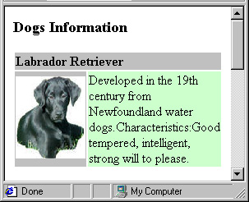

The HTML <marquee> tag is used for scrolling piece of text or image displayed either horizontally across or vertically down your web site page depending on the settings.

<!DOCTYPE html>

<html>

<head>

<title>HTML marquee Tag</title>

</head>

<body>

<marquee>This is basic example of marquee</marquee>

<marquee direction="up">The direction of text will be from bottom to top.</marquee>

</body>

</html>

**CHAPTER 2**

**LINKS, IMAGE AND IMAGE MAPS, FRAME, CSS AND FORM**

**2.1 Linking the Page**

* <A> tag defines an anchor.
* An anchor can be used in two ways:

- To create a link to another document, by using the href attribute

- To create a bookmark inside a document, by using the name attribute

* Main Attributes
  + ***HREF*** - Hypertext Reference: This attribute points the link to a bookmark, another file, either within the same web site or elsewhere on the internet.
  + ***NAME*** - Specifies the name of an anchor.
  + ***ID*** - Specifies a unique id for an element

**External Document References**

* Step one: Mark the location to be jumped to i.e. identify the location in a web page to jump to by giving the location a name.
  + <A Name=“location_name”>
* Step two: While jumping to a specific web page and a specific location on the web page, in addition to the name of the web page to be jumped to, the name of the location on the web page to go to is required.
  + <A Href=“file_name.htm#location_name”>…….</A>

**Internal Document References**

* Since the jump has to be targeted to a specific location in the same document, the same two steps need to be performed as before.
  + <A Name=“location_name”>
  + <A Href= #location_name”>Visit My Home Page</A>

**Link – TARGET Attribute**

* ***TARGET*** – Determines where the destination document will be displayed. The options are:
* **Within the current window or frame** - this is the default;
* **In another window** - This is accomplished by doing the following:
  + providing the name of the desired window
  + Assigning “_blank” to the attribute - this will result in the creation of a new nameless window.
* **In a specified frame** – this will be discussed in more detail within the section on frames.
* Example: <a href = "http:// [www.dictionary.com](http://www.dictionary.com)" TARGET = "_blank"> Open Dictionary</a>

**2.2 Embedding Image**

* **<img>** tag – Inserts a graphic image into an HTML document.
* Main Attributes:
  + ***SRC*** - The image file’s URL. Usually ‘.jpg’ or ‘.gif’ files.
  + ***ALIGN*** - Causes the image to be aligned with respect to the text.
  + ***WIDTH*** */* ***HEIGHT*** - Indicates width and height. Given in:
    - Number of pixels – for a fixed result or, Percentage – for a dynamic fit.
  + SRC = “URL”
  + ALIGN = “TOP | MIDDLE | BOTTOM | LEFT| RIGHT”
  + BORDER = n
  + WIDTH= n (in pixels)
  + HEIGHT= n (in pixels)
  + ALT= “Alternate Text”
* Supports BMP, JPG, GIF and PNG image formats.

**Image – Image & Text A Sample of Code**

**Will be coded as:**

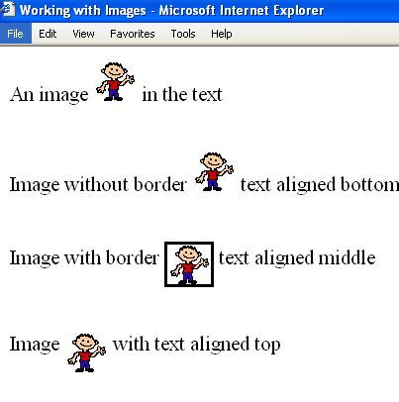

An image <img src = "joe.gif">in the text

Image <img src="joe.gif" ALIGN="top">

with text aligned top

Image with border <img src="joe.gif" BORDER=3 ALIGN="middle" >

text aligned middle

Image without border

<img src = "joe.gif" ALIGN = "bottom">

text aligned bottom

**<img> tag Attributes**

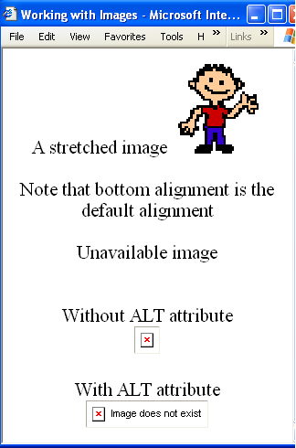

With ALT attribute

<img src = "picture.gif"

ALT = "Image does not exist">

A stretched image

<img src = "joe.gif"

WIDTH = "100" HEIGHT = "100">

**Will be coded as:**

**Images – Image Links**

* Images can also be used as links or bullets in a list.
* Images when put in the anchor tag act as hyperlinks
  + Example:

<a href="http://games.yahoo.com/">

<img src="sbr.gif">

</a>

**2.3 Image Maps**

* An image map presents an ordinary image which is divided (logically) into different areas.
* Each area may be accompanied by an action to be performed when the mouse is clicked while within that area. The action may define:
  + A page to be loaded, or
  + A call to a JavaScript function
* Create an image map using <MAP> tag and <AREA> tag
* An image map is defined in two parts:
  + The **<MAP>** tag is used to define the division into different areas.
  + The USEMAPattribute is added to the **<IMG>** tag to connect the image to the map.

**Image Maps: Map Definition**

* The**<MAP>** tag is used to enclose the area of the map.
  + **NAME** attribute, which assigns a name to the map and links it to the image
  + Example:

<map NAME = "Dogs"> … </map>

* The**<AREA>** tag:
  + Defines an area within the map, as well as an action to be taken when the area is clicked.
* The ***USEMAP*** attribute is added to the **<IMG>** tag to associate the image with the correct map.
* The value of ***USEMAP*** is a map name preceded by the hash sign (**#**).
* Example:<img SRC="dogs.jpg" USEMAP="#Dogs“>
* Main Attributes:
  + ***ALT*** – The label or “Tooltip”, which will appear when the mouse passes over the area.
  + ***HREF*** – Defines the URL of the target to be retrieved when the area’s region is clicked.
  + ***SHAPE*** – Defines the area’s shape.
  + values: **circ**/**circle**, **poly**/**polygon**, **rect**/**rectangle**.
  + ***COORDS*** - Defines the coordinates according to the area’s shape:
    - **circ**/**circle** - X, Y (for the circle’s center) and R (the radius in pixels).
    - **poly**/**polygon** - “X1,Y1,X2,Y2...Xn,Yn.” (n>=3). Each pair of X & Y coordinates defines one vertex of the polygon. The polygon is automatically closed (by the definition of the first and last points).
    - **rect**/**rectangle** – “X1,Y1,X2,Y2”. Each pair of coordinates defines one end of the rectangle’s diagonal.

**2.6 Forms**

* Set of fields that can record information
* To interact with the client
* FORM by itself really cannot do anything
* Forms become powerful when connected to a server application
* A single HTML page can have multiple forms.
* Can be designed using <FORM></FORM> tag
* The form is constructed from the input elements defined within its tags. All values from these input elements are sent at the time the form is submitted.
* <! - -NAME is used for future manipulation of data by scripting language

ACTION indicates a program on the server that will be executed when this form is submitted. Mostly it will be an ASP or CGI script or url.

METHOD indicates the way the form is submitted to the server popular options are GET/POS - ->.

* <form NAME = "form1" ACTION="abc.htm/php" METHOD=GET>

(Form elements go here)

</form>

**Form Elements**

* All types of input items are defined using the **<INPUT>** tag. The only exceptions are the text area, which has its own tag -<TEXTAREA> - and the selection list, which uses the <SELECT> tag.
* <INPUT> tag is used to add elements to the form.
  + NAME = “controlname”
  + TYPE = text / password / checkbox / radio/ submit / reset / button / hidden
  + VALUE
  + MAXLENGTH
  + SIZE

**<INPUT> Items: Text/ Password Fields**

* A text field can be added to the form by typing
  + <INPUT TYPE=“TEXT” NAME=“txtcompany” VALUE=“INFOSYS” SIZE=“10” MAXLENGTH=“15”>
* A password field can be added to the form by typing
  + <INPUT TYPE=“PASSWORD” NAME=“pwdLogin” SIZE=“50” MAXLENGTH=“12”>
  + Input to the field will not be revealed.
* Attributes are:
  + ***VALUE*** is the default value loaded
  + ***SIZE*** sets the size of the field in numbers of characters.
  + ***MAXLENGTH*** specifies max number of characters
  + ***READONLY*** attribute prevents text being revised by the user.

**Text Area**

* Multiline text input
  + <**textarea name=“feedback” rows=3 cols=40>** **default text goes here</textarea>**
* ROWS are the number of rows desired.
* COLS are the no of characters per line.
* Default text is optional
* It is not possible to set the default text using the VALUE attribute
* The default text is to be put into
  + <textarea></textarea> tags

**Selection: Check Box**

<INPUT TYPE=“checkbox” NAME= “contact” VALUE=“email” CHECKED>Notify by email

* + Presents a check box that may be checked and unchecked by the user.
  + Can have multiple checkbox where checked is true
  + VALUE indicates the value to be transmitted to the server.
  + CHECKED sets the text box to be selected by default.

**...**

**<INPUT TYPE=“checkbox” NAME=“first” VALUE=“it’s first” CHECKED>try me!**

**<INPUT TYPE=“checkbox” NAME=“last” VALUE=“I’m in”>don’t touch!**

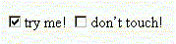

Results in:

**List Box**

* Enclosed by <SELECT> tags.

<SELECT NAME=“Hobbies” MULTIPLE SIZE=“3”>

<OPTION VALUE=“TR”>Travel

<OPTION SELECTED>Reading

<OPTION>Sleeping

<OPTION>Walking

</SELECT>

* SIZE is defined for no. of lines to display
* VALUE indicates what will be sent to the server
* SELECTED sets the default selected item

**Radio Buttons**

<INPUT TYPE="radio" NAME="output" VALUE=“screen” CHECKED>Screen

<INPUT TYPE="radio" NAME="output" VALUE="printer">Printer

* Radio buttons with the same NAME are grouped together (Radio Button Group).
* Only one button can be selected in a group.
* VALUE data to be sent to the server.
* CHECKED will preselect the button.

Which is your favorite character?<br>

<INPUT TYPE="radio" NAME="animal" VALUE="bear">Winnie the pooh

<INPUT TYPE="radio" NAME="animal" VALUE="pig">Piglet

<INPUT TYPE="radio" NAME="animal" VALUE="donkey">Eeyore<br>

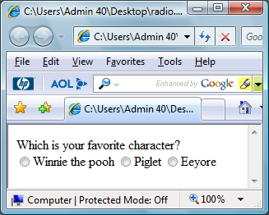

**Hidden Text Field**

<INPUT TYPE=“hidden” NAME=“useinformation” VALUE =“form1”>

* Can be used to transmit default or previously specified data.
* Can be used to pass data from one from to another.
* Cannot be modified by the user
* So it must have a VALUE attribute set
* VALUE data to be sent to the server.

**Buttons**

* The Submit button
  + Sends the form contents to the server when clicked
  + **<INPUT TYPE=submit NAME=cmdsubmit VALUE =“Submit”>**
* The Reset button
  + Resets all the form controls to the default state.
  + **<INPUT TYPE=Reset NAME=cmdReset VALUE="Reset">**
* A button
  + No predetermined action like submit or reset.
  + Script should be written to make it work
  + **<INPUT TYPE=Button NAME=cmdAdd VALUE=“Click Me">.**
* *If the VALUE attribute is assigned a string, the string will be displayed on the button.*

**Form Example**

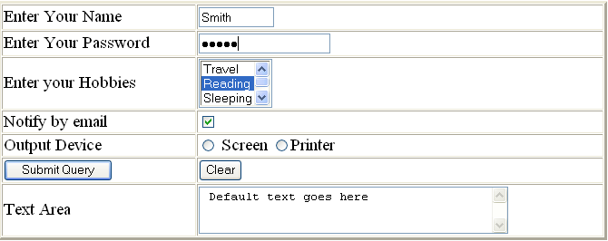

* To display the form elements in a visually appealing way, put them into table cells as shown in the above form.

**HTML sample Page Assignment**

**Assignment - A**

**Task A – ‘SUGGESTED’ SOLUTION**

**EXOTIC BREAKS**

**Web Page Sketches:**

Table – 1 row, 2 columns, 85% width of window, border #996633, background colour #FF9900

**Home Page – index.html**

**Title**: Exotic Breaks – Home Page

Company Name

**h1**

Company Logo – Java Applet waveBannerApplet.class

**Exotic Breaks**

Spry navigation bar – with links to other site pages

**Destinations**

**Far East**

**Africa**

**South America**

**Search**

**Feedback**

**Home**

Sub-heading

**h2**

**Welcome to Exotic Breaks** ~~~~~~~~~~~~~~~~~~~~~~~~~~~~~~~~~~~~~~~~~~~~~~~~~~~~~~~~~~~~~~~~~~~~~~~~~~~~~~~~~~~~~~~~~~~~~~~~~~~~~~~~~~~~~~~~~~~~~~~~~~~~~~~~~~~~~~~~~~~~~~~~~~~~~~~~~~~~~~~~~~~~~~~~~~~~~~~~~~~~~~~~~~~~~~~~~~~~~~~~~~~~~~~~~~

Main page content

**p**

Page content main text

Table – 1 row, 1 column, 85% width of window, border colour #996633.

Image –

machu_picchu.jpg

Footer:

centered, 12pt, italic

Home – Far East – Africa – South America – Search – Feedback – Contact Us

*Designed and maintained by Candidate's Name*

*Last updated May 2010*

Text links to site pages and email link

**Additional Information:`**

Body text: Arial, Helvetica, sans-serif; black; 14px; left-aligned

Background image: texture_yellow_48.jpg

h1 Arial, Helvetica, sans-serif; #FFFF66; 2.2em; centered

h2 Arial, Helvetica, sans-serif; #996633;1.5em; left-aligned

p 1em; line-height: 150%;

Text links: #996633; no underline

Hover links: #FF9933;

Visited links: #9966CC

**Home Page – far_east.html**

**Title**: Exotic Breaks – Holidays in the Far East

Company Name

**h1**

Company Logo – Java Applet waveBannerApplet.class

**Exotic Breaks**

Spry navigation bar – with links to other site pages

**Destinations**

**Far East**

**Africa**

**South America**

**Search**

**Feedback**

**Home**

Sub-heading

**h2**

**Holidays in the Far East** ~~~~~~~~~~~~~~~~~~~~~~~~~~~~~~~~~~~~~~~~~~~~~~~~~~~~~~~~~~~~~~~~~~~~~~

Main page content

**p**

Page content main text

Table – 1 row, 1 column, 85% width of window, border colour #996633.

Image –

temple.jpg

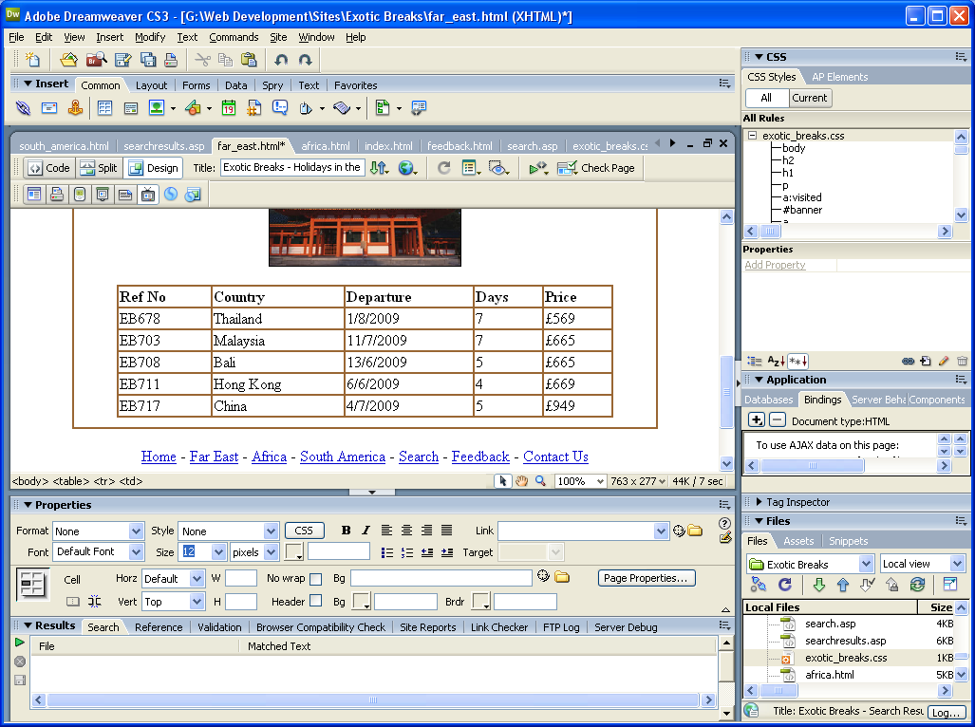

Table containing holiday details

Home – Far East – Africa – South America – Search – Feedback – Contact Us

*Designed and maintained by Candidate's Name*

*Last updated May 2010*

Footer:

centered, 12pt, italic

Text links to site pages and email link

**Additional Information:`**

Body text: Arial, Helvetica, sans-serif; black; 14px; left-aligned

Background image: texture_yellow_48.jpg

h1 Arial, Helvetica, sans-serif; #FFFF66; 2.2em; centered

h2 Arial, Helvetica, sans-serif; #996633;1.5em; left-aligned

p 1em; line-height: 150%;

Text links: #996633; no underline

Hover links: #FF9933;

Visited links: #9966CC

**Structure Diagram**

**Exotic Breaks - Home Page**

**index.html**

External link to mailto:

info@exoticbreaks.co.uk

**Exotic Breaks – Holidays in the Far East**

**far_east.html**

**Exotic Breaks – Customer Feedback**

**feedback.html**

**Exotic Breaks – Holidays in South America**

**south_america.html**

**Exotic Breaks – Search Page**

**search.asp**

**Exotic Breaks – Holidays in Africa**

**africa.html**

**Exotic Breaks – Search Results Page**

**searchresults.asp**

External link to mailto:

info@exoticbreaks.co.uk

**Description of External Style Sheet – exotic_breaks.css**

|  |  |  |
| --- | --- | --- |
| **Selector** | **Attribute** | **Value** |
| **body** | font-family | Arial, Helvetica, sans-serif; |
|  | font-size | 14px; |
|  | background-image | url(images/texture_yellow_48.jpg); |
| **h1** | font-size | 2.2em; |
|  | Color | #FFFF66; |
|  | text-align | center; |
| **h2** | font-size | 1.5em; |
|  | Color | #996633; |
| **p** | font-size | 1em; |
|  | line-height | 150%; |
| **a** | Color | #996633; |
|  | text-decoration | none; |
| **a:visited** | Color | #9966CC; |
| **a:hover** | Color | #FF9933; |

**index.html**

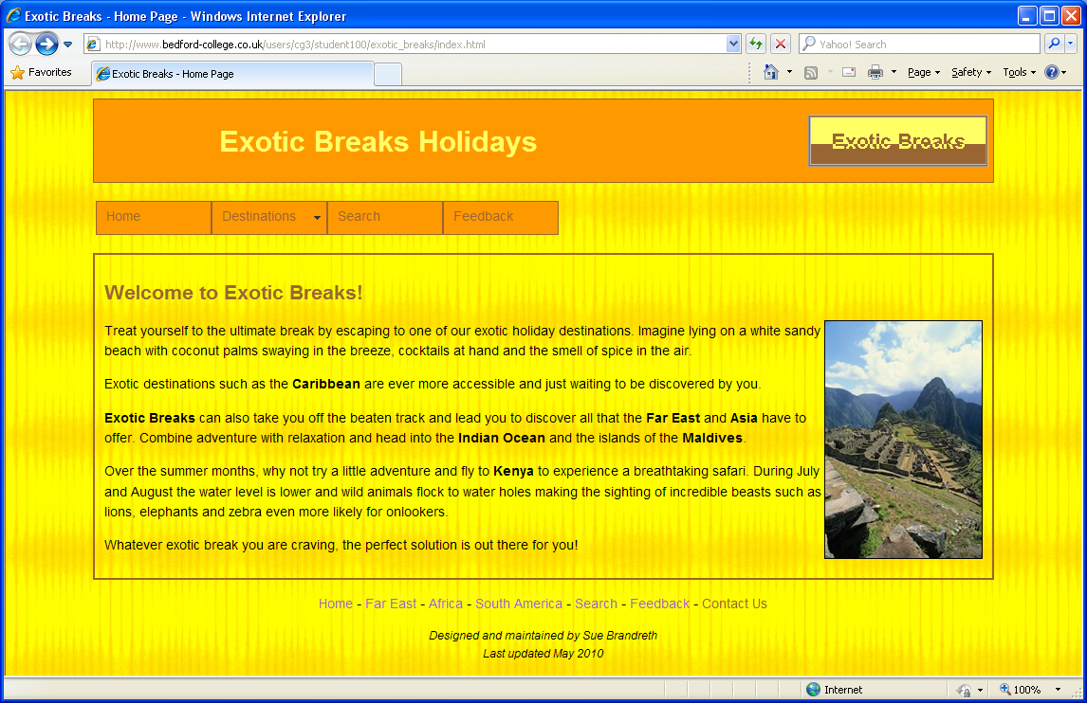

**index.html**

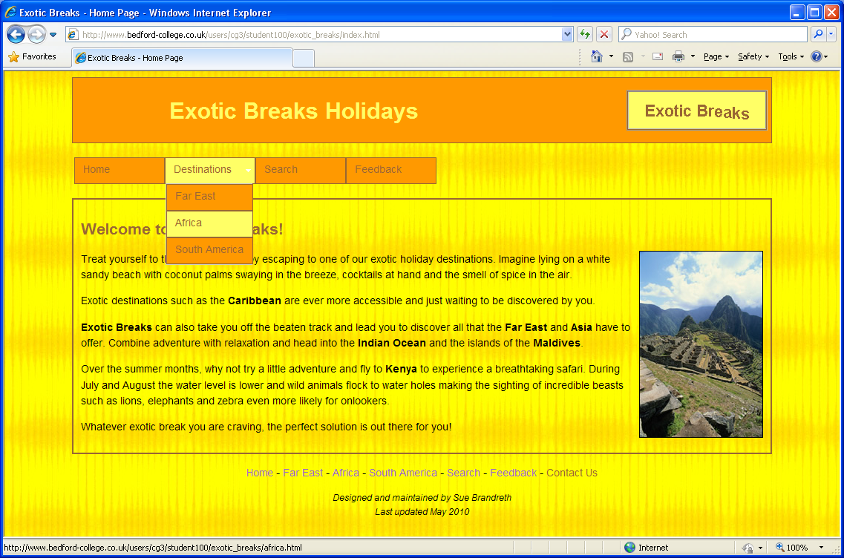

**far_east.html**

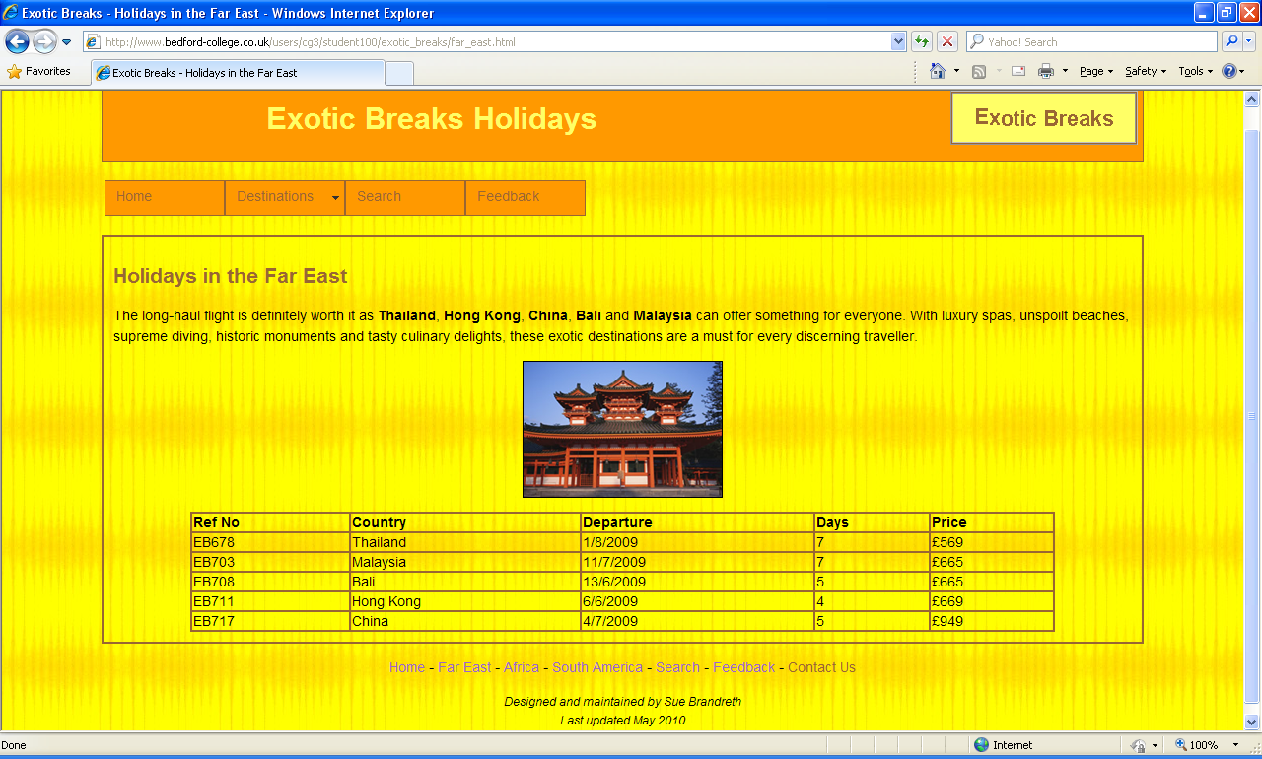

**africa.html**

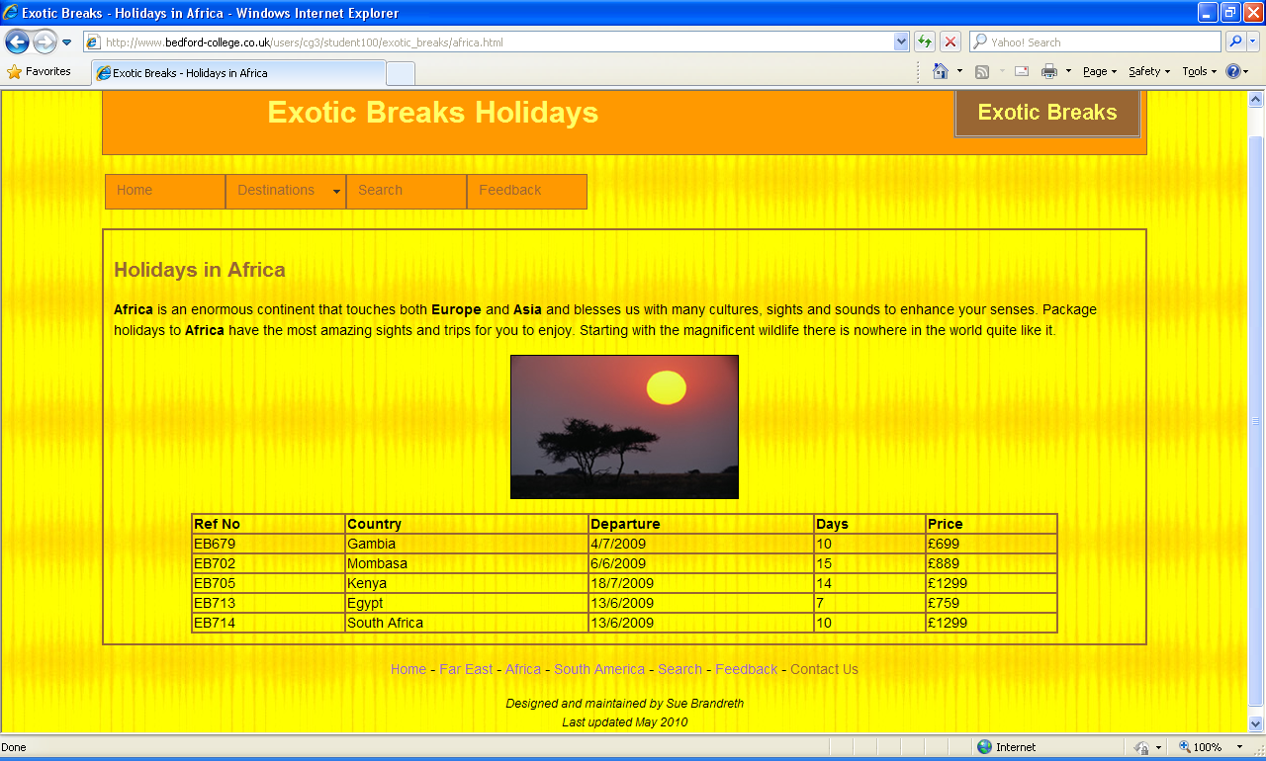

**south_america.html**

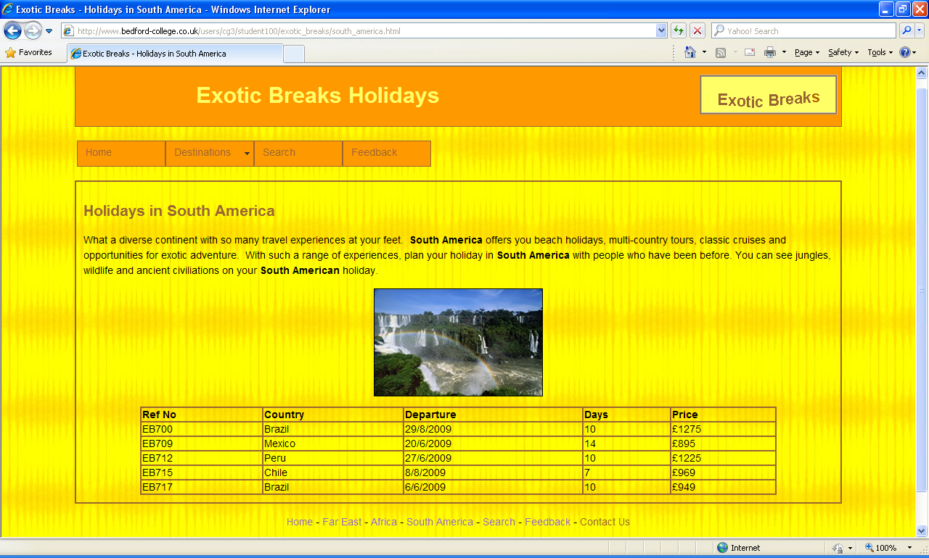

**search.html**

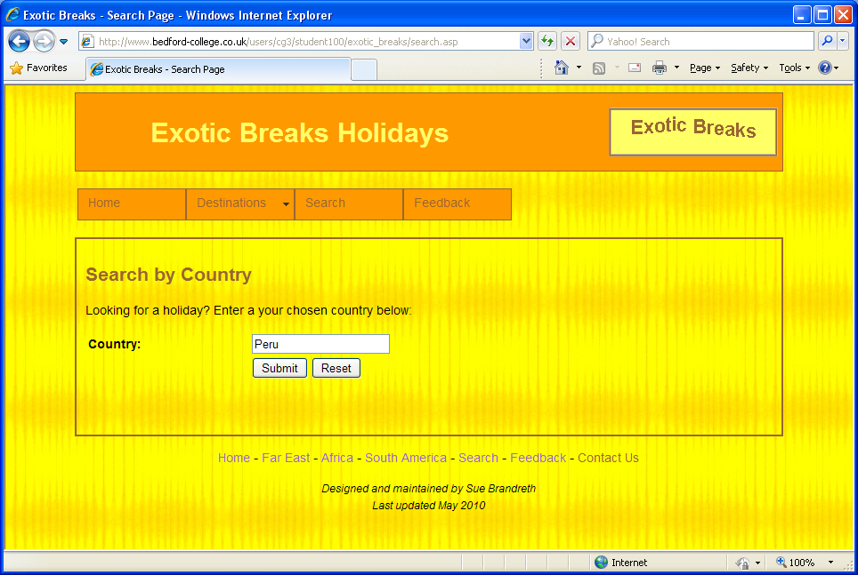

**searchresults.html**

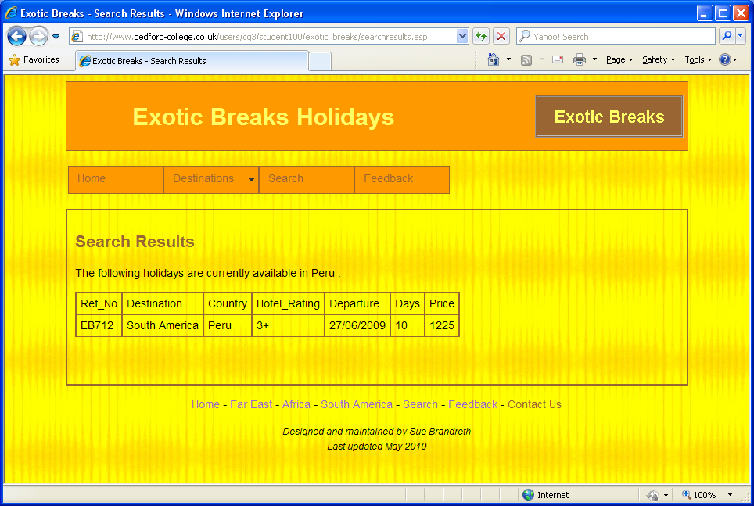

**feedback.html**

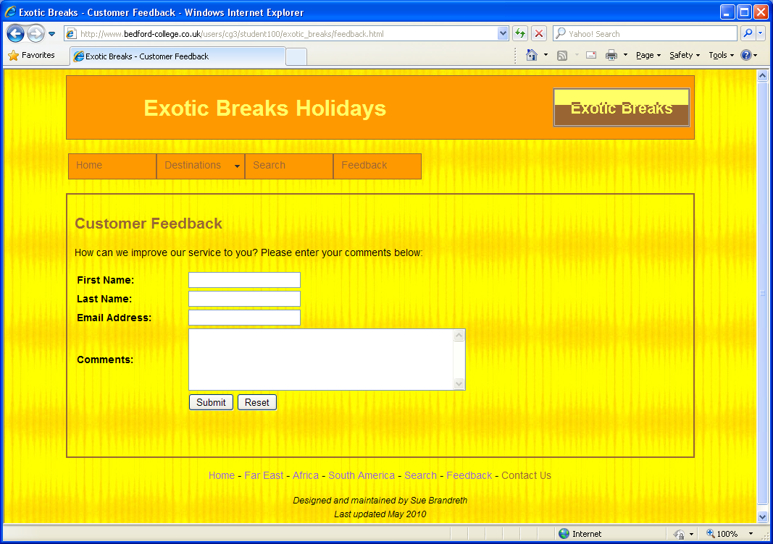

**Cascading Style Sheet**

**What is CSS?**

* CSS stands for Cascading Style Sheets
* Styles define how to display HTML elements
* Styles are normally stored in Style Sheets
* Styles were added to HTML 4.0 to solve a problem
* External Style Sheets can save you a lot of work
* External Style Sheets are stored in CSS files
* Multiple style definitions will cascade into one

What style will be used when there is more than one style specified for an HTML element?

Generally speaking we can say that all the styles will “cascade” into a new “virtual” style sheet by the following rules, where number four has the highest priority:

1. Browser default
2. External style sheet
3. Internal style sheet (inside the <head> tag)
4. Inline style (inside an HTML element)

So, an inline style (inside an HTML element) has the highest priority, which means that it will override a style declared inside the <head> tag, in an external style sheet, or in a browser (a default value).

**Internal Style Sheet**

An internal style sheet should be used when a single document has a unique style. You define internal styles in the head section by using the <style> tag, like this:

**CSS Syntax**

<style type=”text/css”>

body{

Color : black; background : white;

}

</style>

Example of Internal Style Sheet:

<html>

<head>

<title>replace with your document’s title</title>

<style type=”text/css”>

body { color : black; background : white; }

</style>

</head>

<body>

Replace with your document’s content

</body>

</html>

Output is ……………………………..

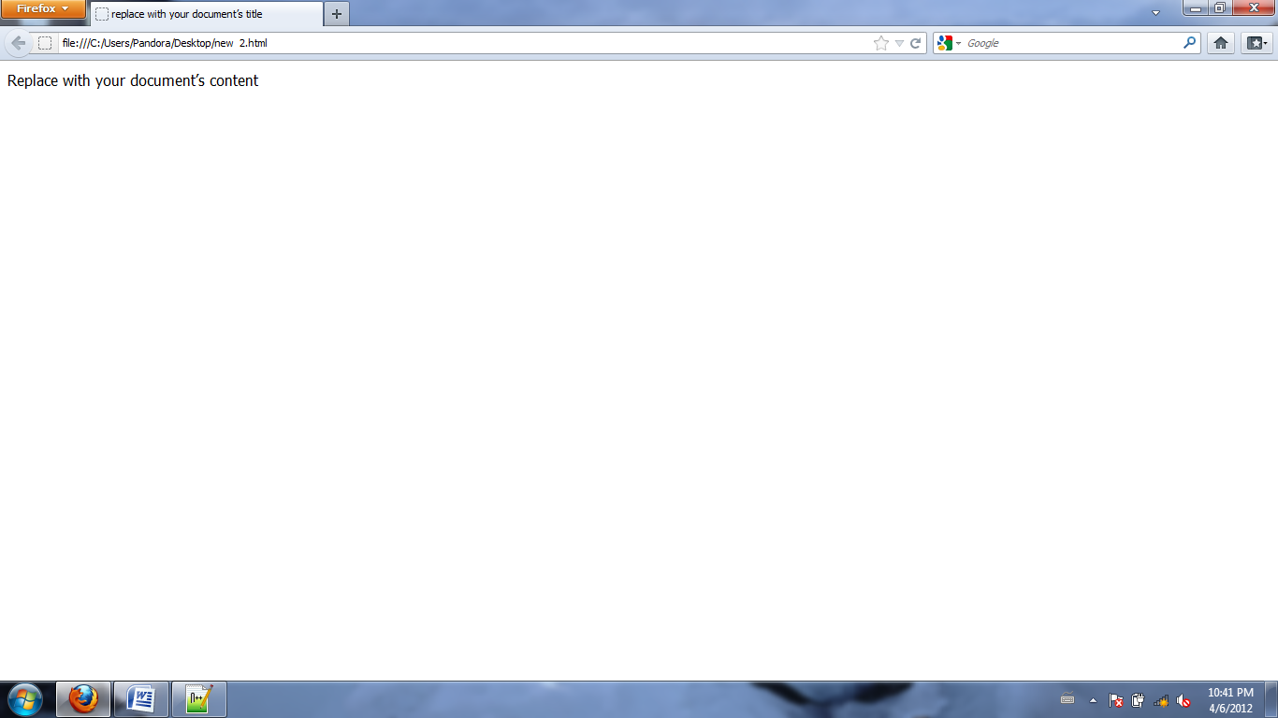

**Inline Style Sheet**

An inline style loses many of the advantages of style sheets by mixing content with presentation. Use this method sparingly, such as when a style is to be applied to a single occurrence of an element.

To use inline styles you use the style attributes in the relevant tag. The style attribute can contain any CSS property. The example shows how to change the color and the left margin of a paragraph:

<p style=”color : sienna; margin-left : 20px”>

This is a paragraph

</p>

Example of Inline Style Sheet:

<html>

<body>

<p style=”color : sienna; margin-left : 70px”>

This is a paragraph

</p>

</body>

</html>

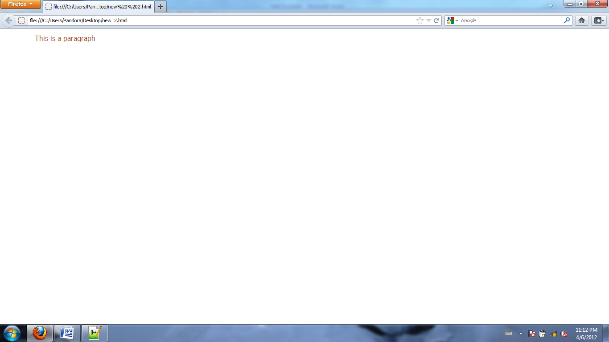Output is …………………………………...

**External Style Sheet**

An external style sheet is ideal when the style is applied to many pages. With an external style sheet, you can change the look of an entire Web site by changing one file. Each page must link to the style using the <link> tag. The <link> tag goes inside the head section:

<link type=”text/css” rel=”stylesheet” href=”style.css”>

Example of External Style Sheet:

<html>

<head>

<title>replace with your document’s title</title>

<link type=”text/css” rel=”stylesheet” href=”style.css”>

</head>

<body>

replace with your document’s content replace with your document’s content replace with your document’s content replace with your document’s content replace with your document’s content replace with your document’s content replace with your document’s content replace with your document’s content replace with your document’s content replace with your document’s content replace with your document’s content replace with your document’s content

</body>

</html>

The link element’s rel attribute must be set to the value “stylesheet” to allow the browser to recognize that the href attribute gives the Web address (URL) for your style sheet. A simple stylesheet file might look like the following:

/* style.css – a simple style sheet */

body{

margin-left : 10% ; margin-right : 10% ;

color : black ; background : white;

}

Output is ………………………..........

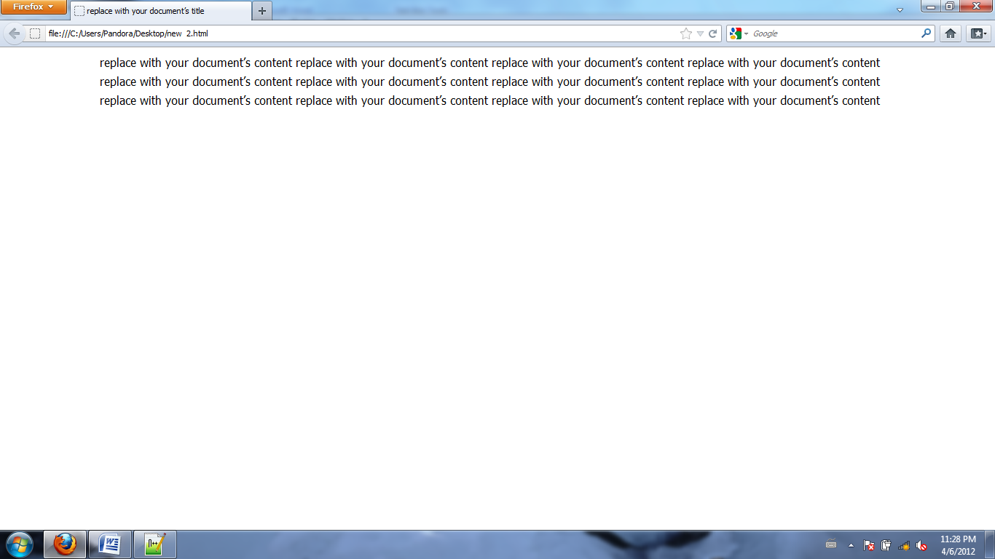

**What about browsers that don’t support CSS?**

Older browsers, that is to say before Netscape 4.0 and Internet Explorer 4.0, either don’t support CSS at all or do so inconsistently. For these browsers you can still control the style by using HTML itself.

**Example one:**

<html>

<head>

<style type=”text/css”>

body { background-color : black; }

h1 { background-color : white; }

h2 { background-color : silver; }

p { background-color : white; }

</style>

</head>

<body>

<h1>This is header 1</h1>

<h2>This is header 2</h2>

<p>This is a paragraph</p>

</body>

</html>

Output is ……………………………………

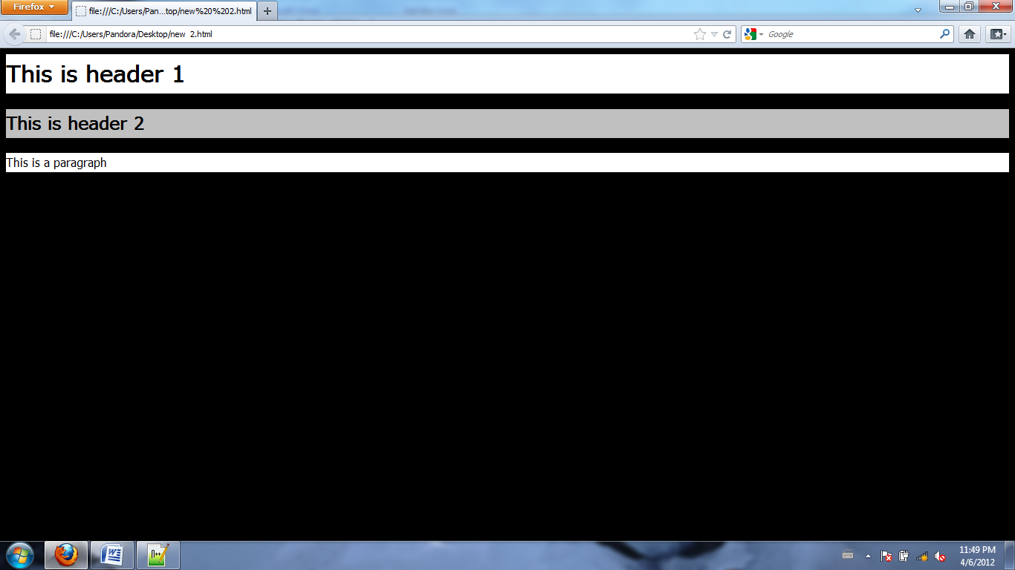

**Example Two:**

<html>

<head>

<style type=”text/css”>

h1 { color : #00ff00 }

h2 { color : red }

p { color : rgb(0,0,255) }

</style>

</head>

<body>

<h1>This is header 1</h1>

<h2>This is header 2</h2>

<p>This is a paragraph</p>

</body>

</html>

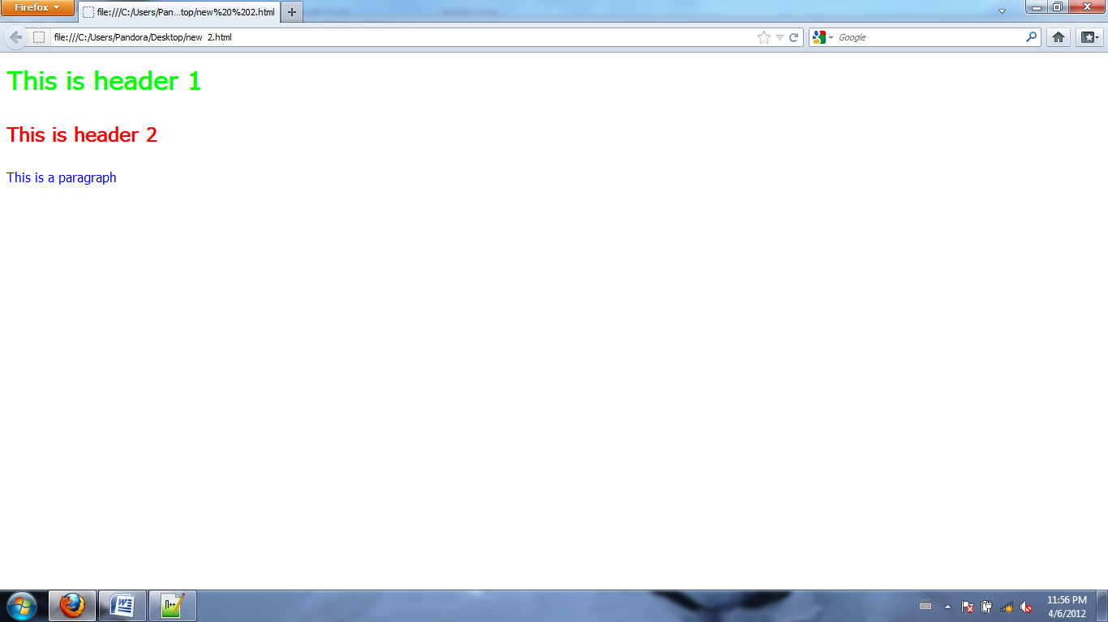Output is ………………………………………..

**Example Three:**

<html>

<head>

<style type=”text/css”>

H1 { letter-spacing : -3px }

H4 { letter-spacing : 0.5cm }

P { word-spacing : 30px }

</style>

</head>

<body>

<h1>This is header 1</h1>

<h4>This is header 4</h4>

<p>This is some text. This is some text.</p>

</body>

</html>

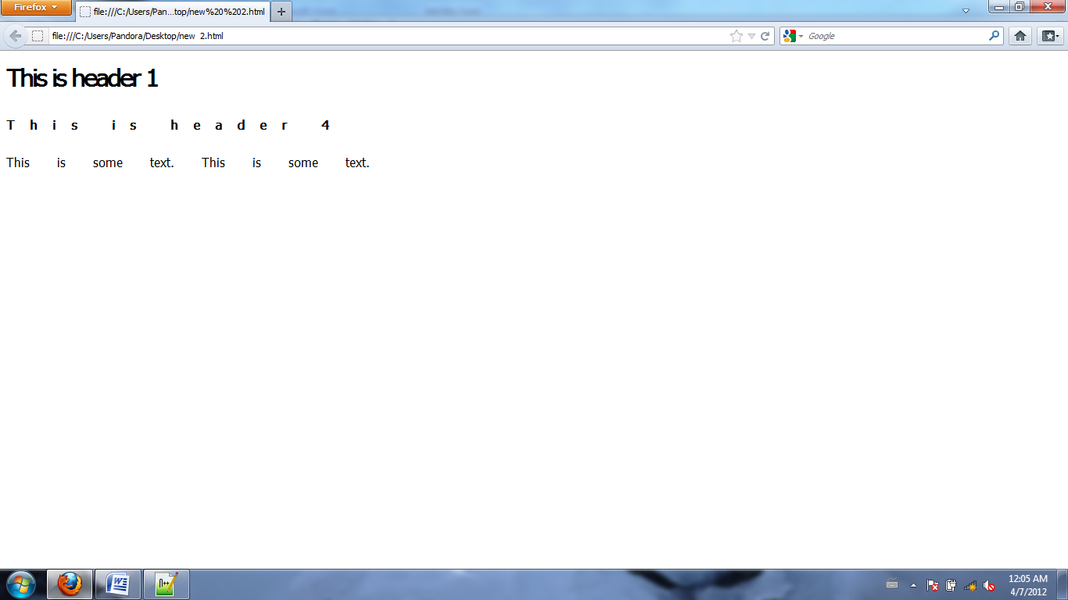Output is ……………………………………………..

**Example four:**

<html>

<head>

<style type=”text/css”>

H1 { text-decoration : overline }

H2 { text-decoration : line-through }

H3 { text-decoration : underline }

P { text-indent : 1cm }

A { text-decoration : none }

</style>

</head>

<body>

<h1>This is header 1</h1>

<h2>This is header 2</h2>

<h3>This is header 3</h3>

<p>This is some text in a paragraph. This is some text in a paragraph. This is some

text in a paragraph. This is some text in a paragraph. This is some text in a paragraph.

This is some text in a paragraph.

</p>

</body>

</html>

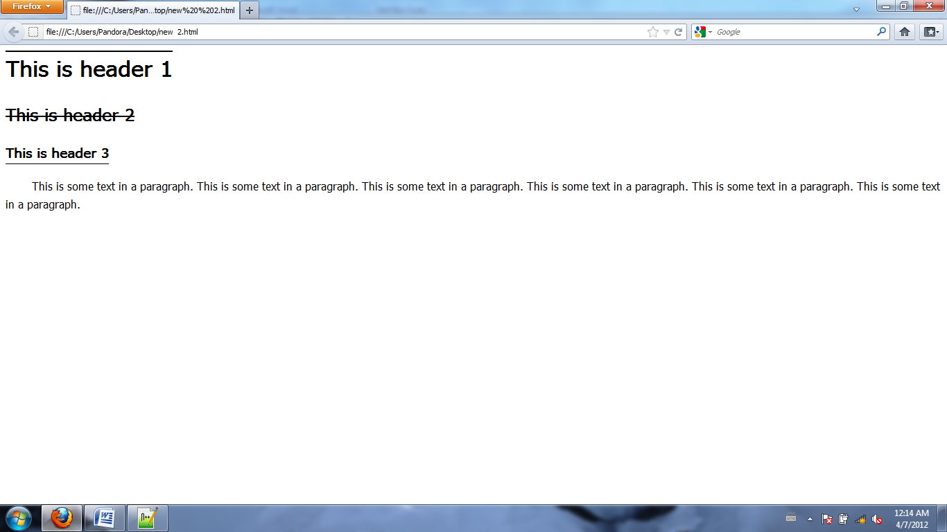

**Example Five:**

/* The HTML file below links to an external style sheet with the <link> tag: */

<html>

<head>

<link rel=”stylesheet” type=”text/css” href=”ex2.css”/>

</head>

<body>

<h1>This is header 1</h1>

<hr/>

<p>You can see that the style sheet formats the text</p>

<p><a href=”../wsdindex.html” target=”_blank”>This is a link</a></p>

</body>

</html>

/* This is the style sheet file(ex2.css): */

body { background-color : tan }

h1 { color : maroon ; font-size : 20pt }

hr { color : navy }

p { font-size : 11pt ; margin-left : 15px }

a:link { color : green }

a:visited { color : yellow }

a:hover { color : black }

a:active { color : blue }

Output is ……………………….

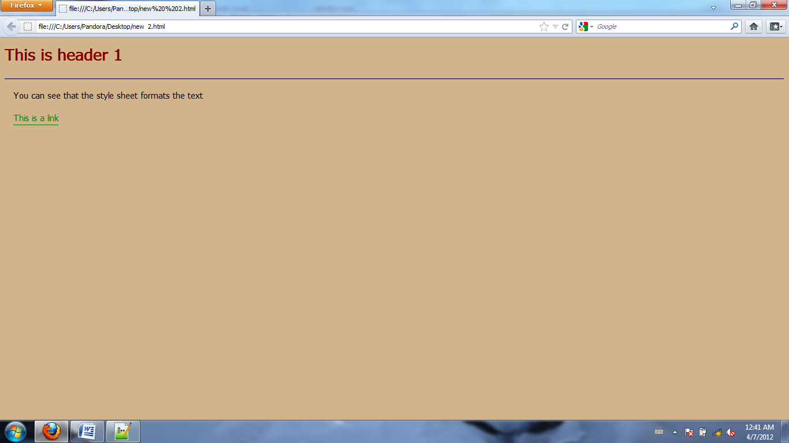

**Example Six:**

<html>

<head>

<style type=”text/css”>

body{

background-image : url(‘example.jpg’);

background-repeat : no-repeat;

background-attachment : fixed;

background-position : 30%20%;

}

</style>

</head>

<body>

<p><b>Note:</b> For this to work in Mozilla, the background-attachment property

must be sent to “fixed”.</p>

</body>

</html>

Output is …………………………………………………………

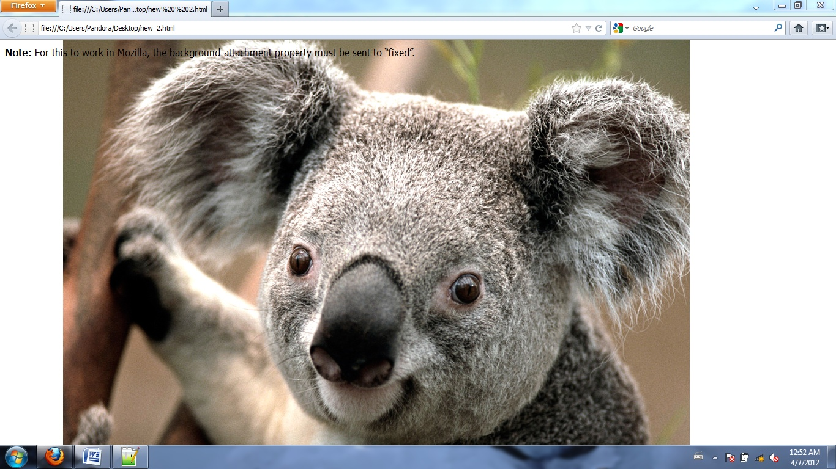

**Exam­­ple Seven:**

<html>

<head>

<title>CSS Link</title>

<style type=”text/css”>

a:visited{

color : red;

text-decoration : none;

font-size : 14px;

}

a:link{

color : red;

text-decoration : none;

font-size : 14px;

}

a:hover{

color : orange;

text-decoration : none;

font-size : 16px;

}

</style>

</head>

<body>

<p>

<a href=”#”>CSS LINK</a>

</p>

</body>

</html>

**Example Eight:**

<html>

<head>

<style type=”text/css”>

p.soliddouble { border-style : solid double }

p.doublesolid { border-style : double solid }

p.groovedouble { border-style : groove double }

p.three { border-style : solid double groove }

</style>

</head>

<body>

<p class=”soliddouble”>Some text</p>

<p class=”doublesolid”>Some text</p>

<p class=”groovedouble”>Some text</p>

<p class=”three”>Some text</p>

</body>

</html>

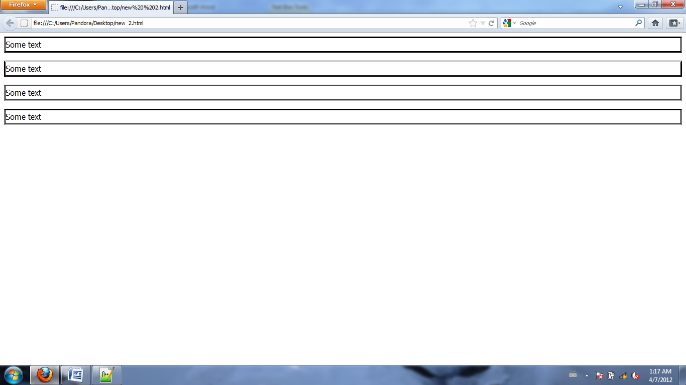Output is ……………………………………………..

**HOW TO USE CLASS IN CSS**

CSS Syntax of Class

.center { text-align : center }

In the code below both the h1 element and the p element have class=”center”. This means that both elements will follow the rules in the “.center” selector:

<html>

<head>

<style type=”text/css”>

.center { text-align : center }

</style>

</head>

<body>

<h1 class=”center”>This heading will be center-aligned</h1>

<p class=”center”>This paragraph will also be center-aligned.</p>

</body>

</html>

**Example:**

<html>

<head>

<style type=”text/css”>

.highlight { background-color : yellow }

</style>

</head>

<body>

<p>

<span class=”highlight”>This is a text.</span>

This is a text. This is a text. This is a text. This is a text. This is a text.

This is a text. This is a text. This ia a text.

<span class=”highlight”>This is a text.</span>

</p>

</body>

</html>

Output is …………………………………..

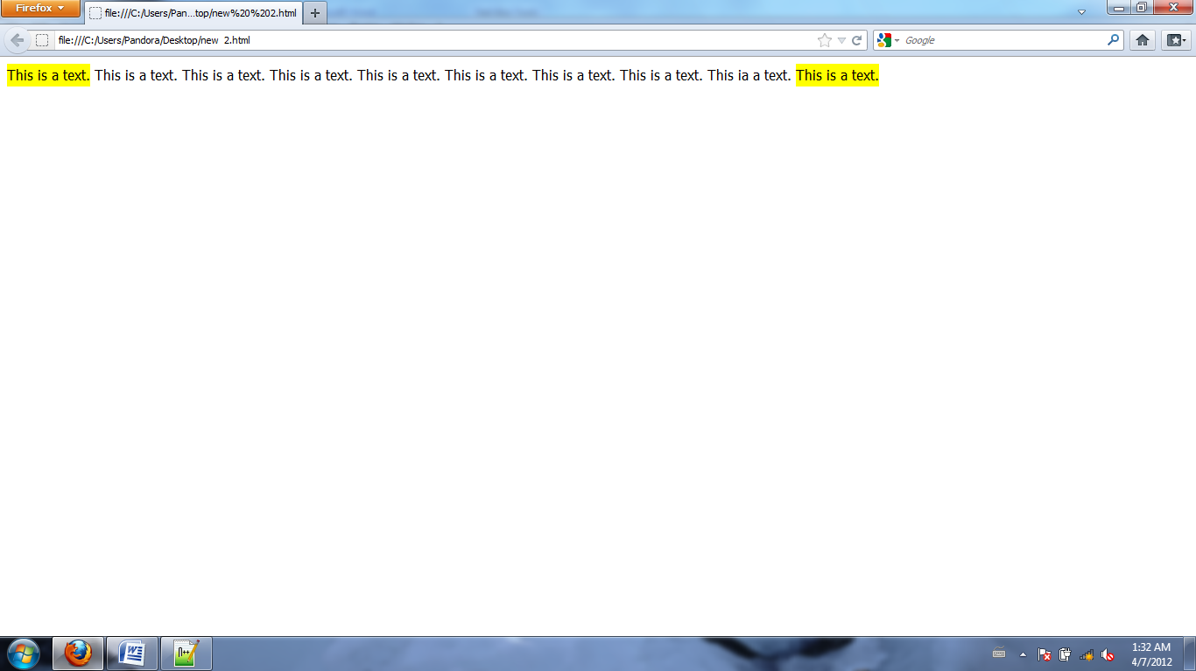

**CSS Text Example**

<html>

<head>

<style type="text/css">

h1 { color : red }

h2 { letter-spacing : -3px }

h3.under { text-decoration : underline }

h3.over { text-decoration : overline }

p.align { text-align : center }

p.indent { text-indent : 1cm }

p.capital { text-transform : capitalize }

p.upper { text-transform : uppercase }

p.lower { text-transform : lowercase }

p.word { word-spacing : 30px }

</style>

</head>

<body>

<h1>This is header 1</h1>

<h2>This is header 2</h2>

<h3 class="under">This is Underline</h3>

<h3 class="over">This is Overline</h3>

<p class="align">This is Align</p>

<p class="indent">This is Text-Indent</p>

<p class="capital">This is Capitalize</p>

<p class="upper">This is UpperCase</p>

<p class="lower">This is LowerCase</p>

<p class="word">This is some Text</p>

</body>

</html>

Output is …………………………………

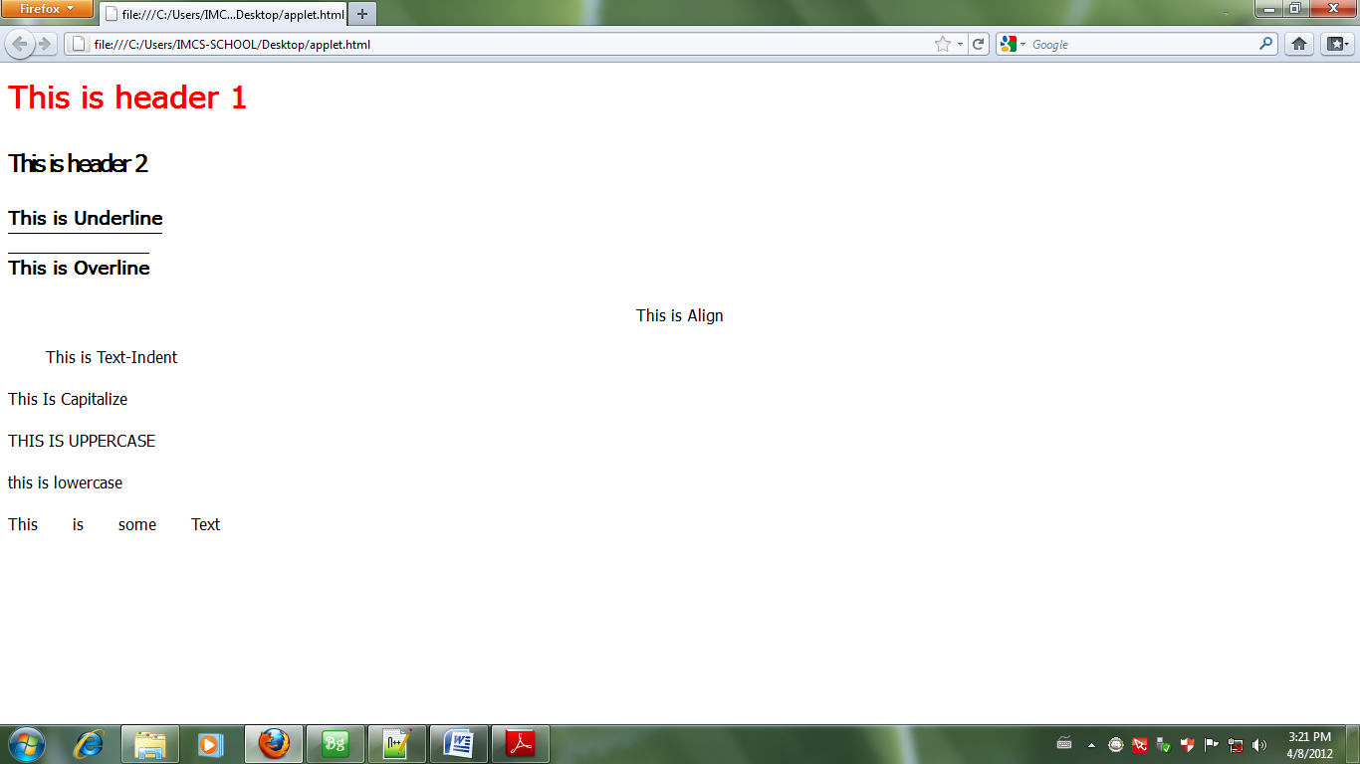

**CSS Font Example**

<html>

<head>

<style type="text/css">

p.test1 { font-style : italic }

p.test2 { font-variant : small-caps }

p.test3 { font-weight : bold }

p.test4 { font-size : 30px }

p.test5 { font-family : Arial, Verdana, sanserif }

</style>

</head>

<body>

<p class="test1">This is Italic</p>

<p class="test2">This is Small-Caps</p>

<p class="test3">This is bold</p>

<p class="test4">This is 30px font size</p>

<p class="test5">This is font family</p>

</body>

</html>

Output is …………………………………………..

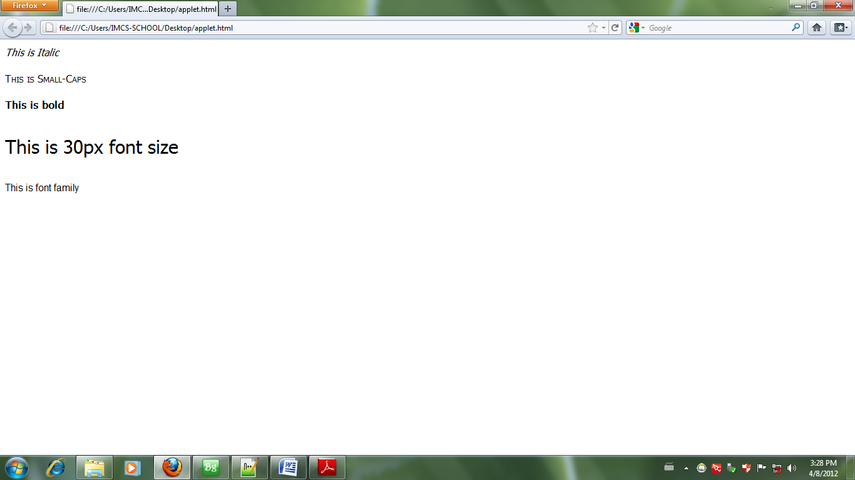

**CSS Border Example One:**

<html>

<head>

<style type="text/css">

h1{

border-width : thick;

border-style : dotted;

border-color : gold

}

h2{

border-width : 20px;

border-style : outset;

border-color : red

}

h3.test1{

border-width : medium;

border-style : dashed;

border-color : purple

}

h3.test2{

border-width : thin;

border-style : inset;

border-color : blue

}

</style>

</head>

<body>

<h1>dotted</h1>

<h2>outset</h2>

<h3 class="test1">dashed</h3>

<h3 class="test2">inset</h3>

</body>

</html>

Output is …………………………………………………………

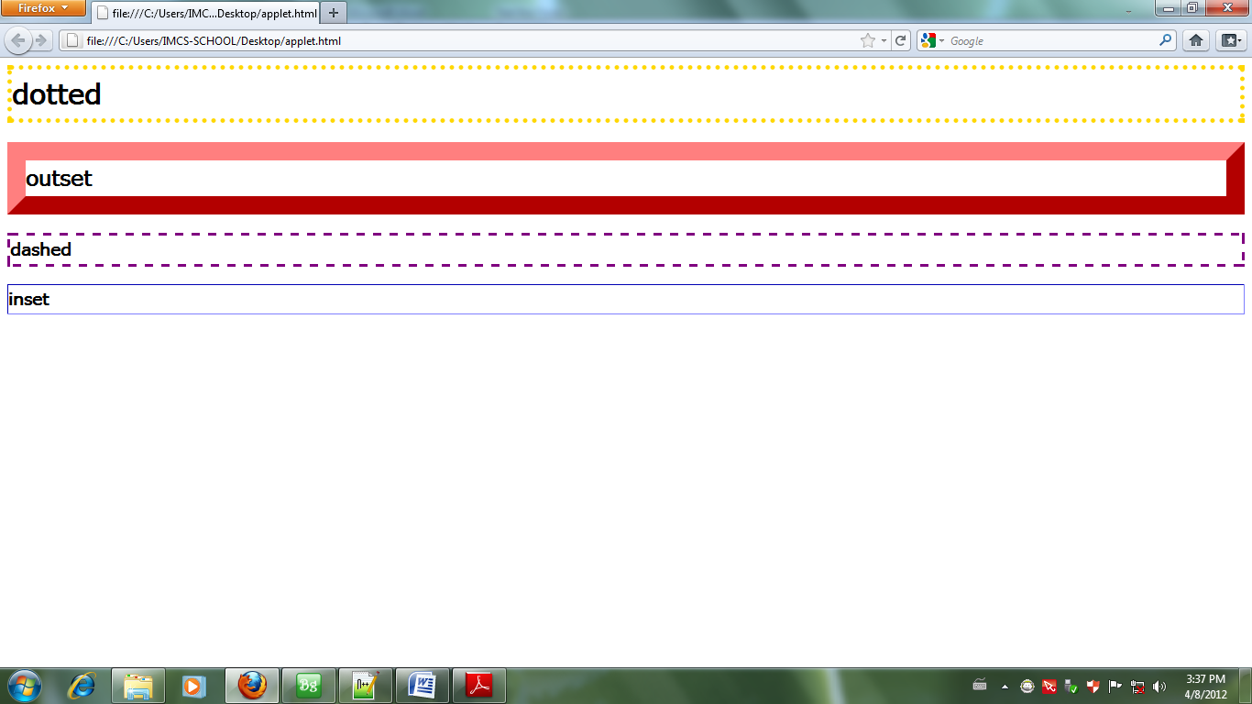

**CSS Border Example Two:**

<html>

<head>

<style type="text/css">

h3.test3{

border-width : thick;

border-style : ridge;

border-color : black

}

h3.test4{

border-width : thin;

border-style : solid;

border-color : black

}

h3.test5{

border-width : thick;

border-style : double;

border-color : black

}

h3.test6{

border-width : thick;

border-style : groove;

border-color : black

}

</style>

</head>

<body>

<h3 class="test3">ridge</h3>

<h3 class="test4">solid</h3>

<h3 class="test5">double</h3>

<h3 class="test6">groove</h3>

</body>

</html>qaa

Output is …………………………………….

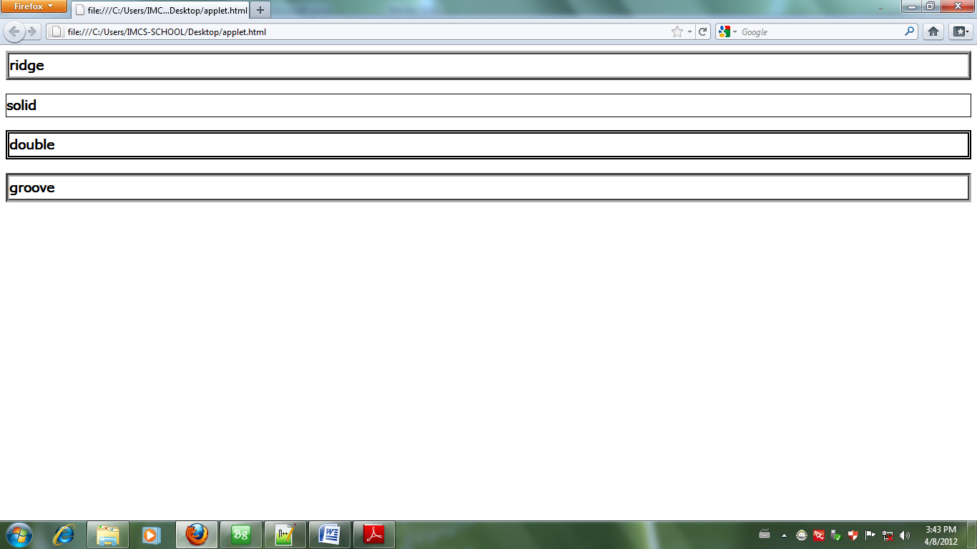

**CSS Border Example Three:**

<html>

<head>

<style type="text/css">

h2{

border-top-width : 10px;

border-top-style : dotted;

border-top-color : red;

border-bottom-width : 10px;

border-bottom-style : dashed;

border-bottom-color : blue;

border-right-width : 10px;

border-right-style : ridge;

border-right-color : green;

border-left-width : 10px;

border-left-style : solid;

border-left-color : orange

}

</style>

</head>

<body>

<h2>Border</h2>

</body>

</html>

Output is ……………………………………………………………..

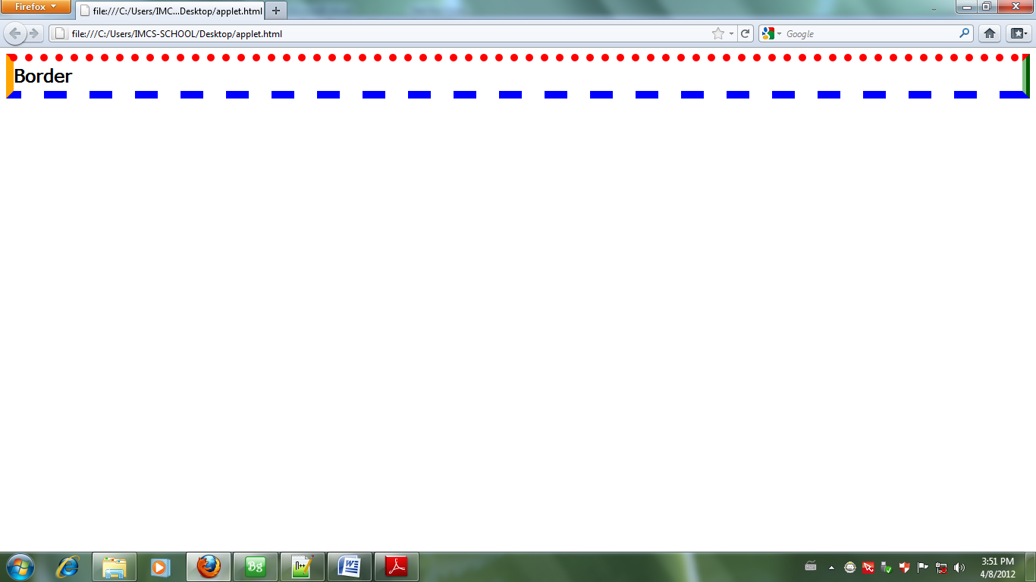

**CSS Margin Example:**

<html>

<head>

<style type="text/css">

body{

margin-top : 100px;

margin-right : 40px;

margin-bottom : 10px;

margin-left : 70px

}

(OR)

body{

margin : 100px 40px 10px 70px;

}

</style>

</head>

<body>

This is margin test. This is margin test. This is margin test. This is margin test.

This is margin test. This is margin test. This is margin test. This is margin test.

This is margin test. This is margin test. This is margin test. This is margin test.

</body>

</html>

Output is ………………………………………………………

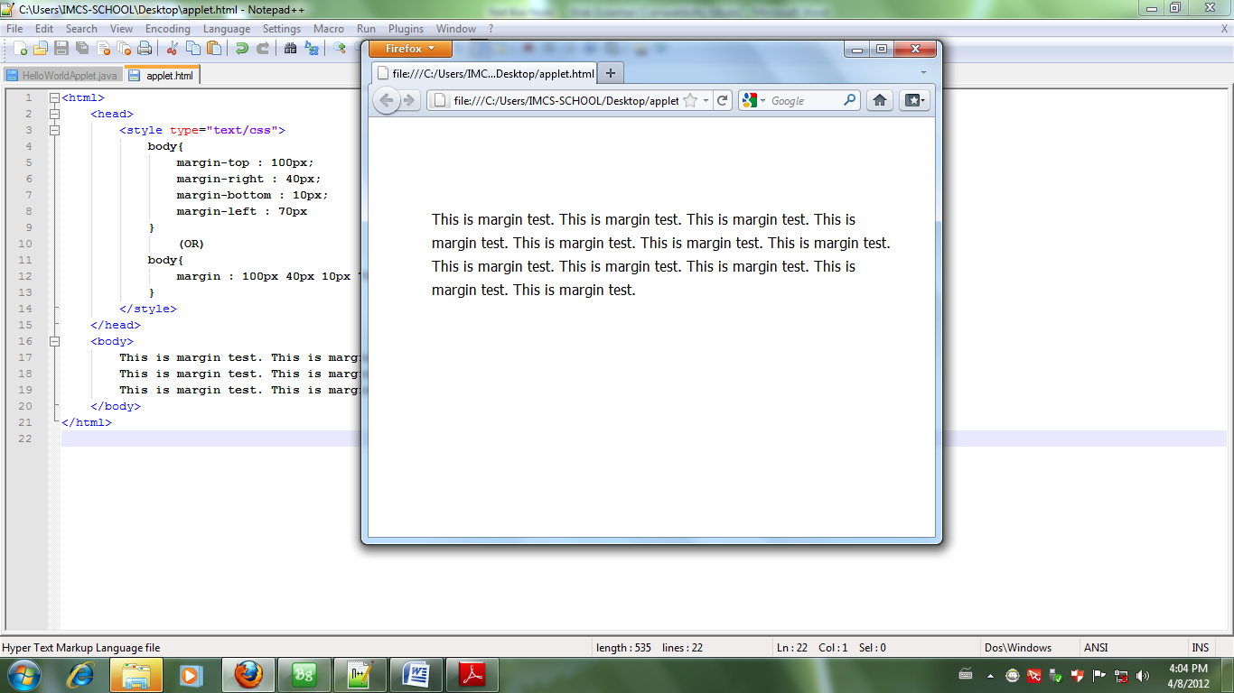

**CSS Padding Example:**

<html>

<head>

<style type="text/css">

h1 {

background : yellow;

padding-top : 20px;

padding-right : 20px;

padding-bottom : 20px;

padding-left : 80px

}

h2 {

background : orange;

padding-left : 120px

}

</style>

</head>

h1 {

background : yellow;

padding : 20px 20px 20px

}

<body>

<h1>Header 1</h1>

<h2>Header 2</h2>

</body>

</html>

Output is ……………………………………

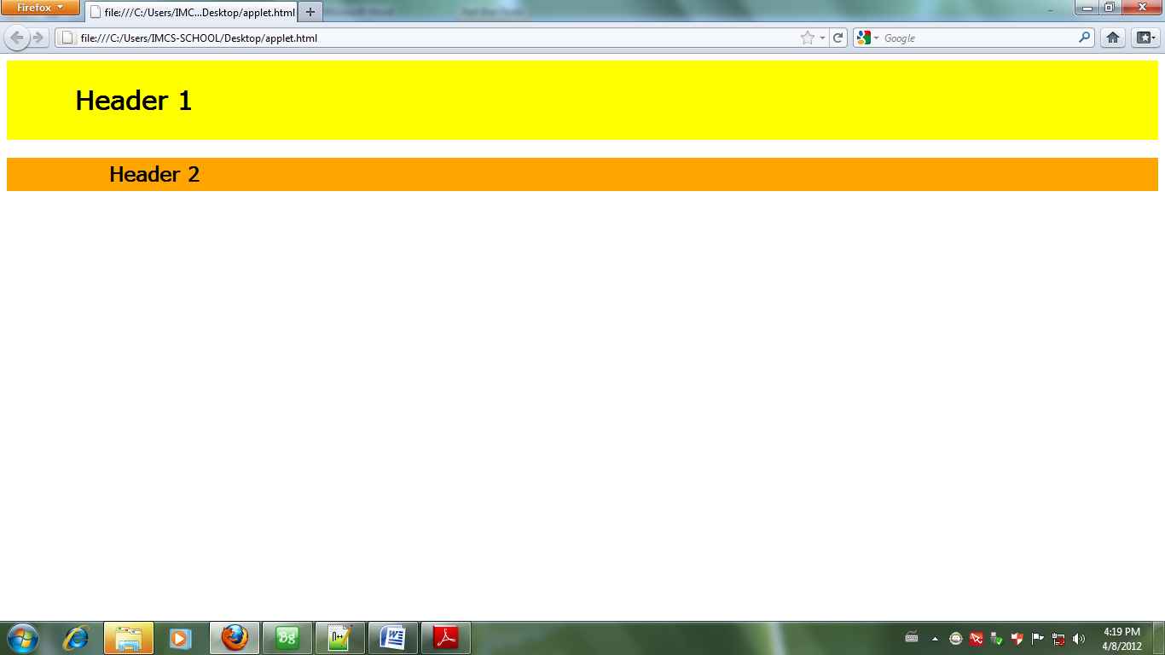

**CSS List Example One:**

<html>

<head>

<style type="text/css">

ol {

list-style-position : inside;

list-style-image : url(Desert.jpg)

}

</style>

</head>

<body>

<ol>

<li>One</li>

<li>Two</li>

<li>Three</li>

</ol>

</body>

</html>

Output is ……………………………………..

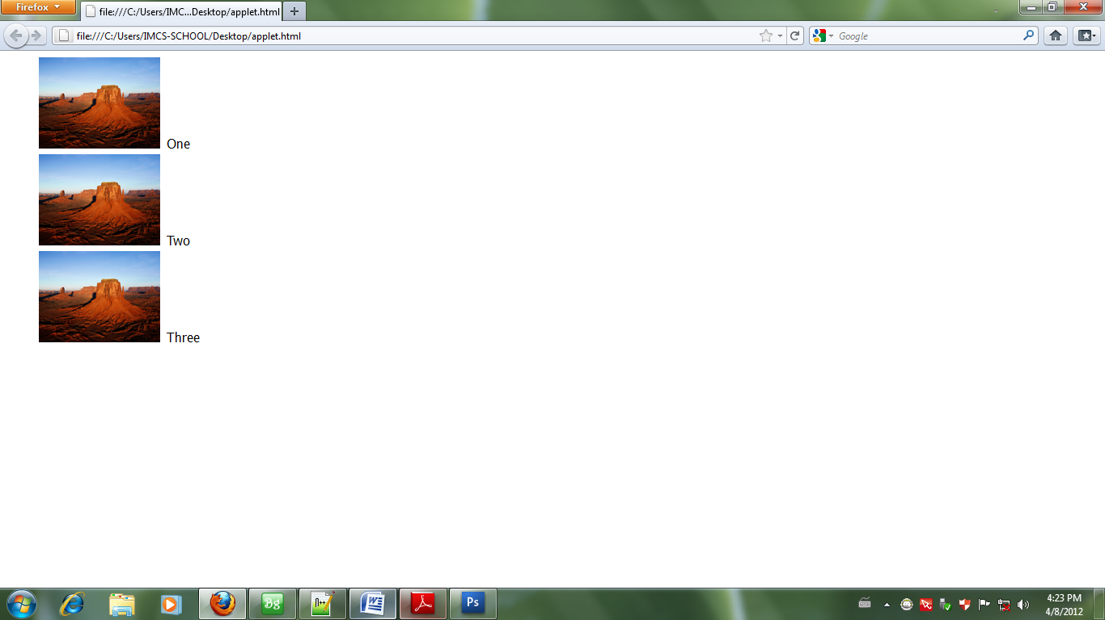

**CSS List Example Two:**

<html>

<head>

<style type="text/css">

ol {

list-style-type : decimal

}

</style>

</head>

<body>

<ol>

<li>One</li>

<li>Two</li>

<li>Three</li>

</ol>

</body>

</html>

Output is …………………………………………….

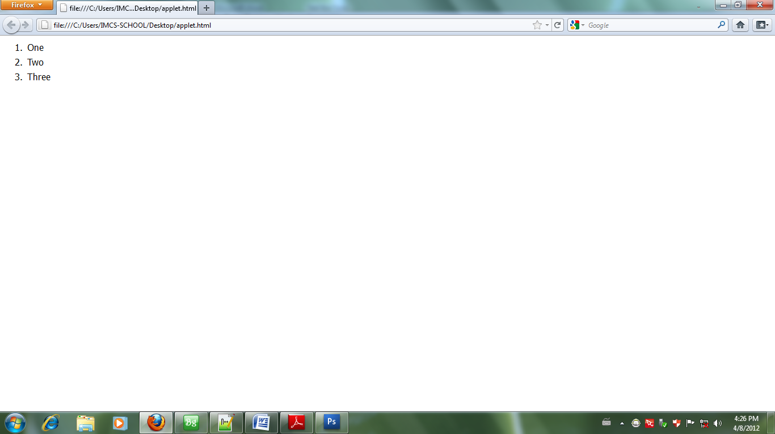

**CSS sample1 (image box)**

sample1.html

|  |
| --- |
| <!DOCTYPE html>  <html>  <head>  <title></title>  <style type="text/css">  .box{  width: 200px;  height: 230px;  border: 1px solid gray;  text-align: center;  padding: 10px;  border-radius: 5px;  box-shadow: 5px 10px 15px 2px gray;  }  .box:hover{  box-shadow: 0px 0px 0px 0px white;  }  </style>  </head>  <body>  <div class="box">  <img src="images/a.jpg" width="180px" height="170px">  <p> Cute Baby </p>  </div>  </body>  </html> |

**Output :**

|  |  |
| --- | --- |
|  | **Afer hover** |

**samplePage2.html (crate column)**

|  |
| --- |
| <!DOCTYPE html>  <html>  <head>  <title></title>  <style type="text/css">  .row{  width: 1000px;  margin: 0 auto;  }  .sub{  width: 300px;  float: left;  text-align: justify;  padding: 15px;  }  .mid{  border-left: 1px dashed black;  border-right: 1px dashed black;  }    </style>  </head>  <body>  <div class="row">    <div class="sub">  <p>Lorem ipsum dolor sit amet, consectetur  adipisicing elit, sed do eiusmod… </p>  <p>Lorem ipsum dolor sit amet, consectetur  adipisicing elit, sed do eiusmod…..</p>  </div>  <div class="sub mid">  <p>Lorem ipsum dolor sit amet, consectetur  adipisicing elit, sed do eiusmod….</p>  <p>Lorem ipsum dolor sit amet, consectetur  adipisicing elit, sed do eiusmod …</p>  </div>  <div class="sub">  <p>Lorem ipsum dolor sit amet, consectetur  adipisicing elit, sed do eiusmod …</p>  <p>Lorem ipsum dolor sit amet, consectetur  adipisicing elit, sed do eiusmod….</p>  </div>  </div>  </body>  </html> |

Output

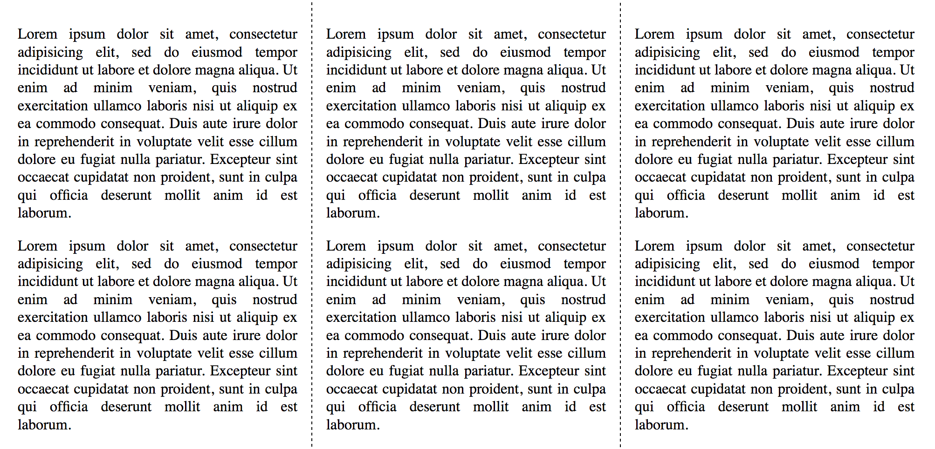

Sample Page 3

samplePage3.html

|  |
| --- |
| <!DOCTYPE html>  <html>  <head>  <title></title>  <style type="text/css">  .container{  width: 1000px;  margin: 0 auto;  }  .header,.footer{  background: gray;  color: white;  clear: both;  padding: 5px;  }  .left{  width: 200px;  }  .mid{  width: 500px;  }  .right{  width: 200px;  }  .left,.right,.mid{  float: left;  }  .left ul li{  list-style-type: none;  }    </style>  </head>  <body>  <div class="container">  <div class="header"><h1>Info Myanmar College</h1></div>  <div class="row">  <div class="left">  <ul>  <li><a href="#">Link 1</a></li>  <li><a href="#">Link 2</a></li>  <li><a href="#">Link 3</a></li>  <li><a href="#">Link 4</a></li>  <li><a href="#">Link 5</a></li>  </ul>  </div>  <div class="mid">  <p>Lorem ipsum dolor sit amet, consectetur adipisicing elit, sed do eiusmod  tempor incididunt ut labore et dolore magna aliqua. Ut enim ad minim veniam,  quis nostrud exercitation ullamco laboris nisi ut aliquip ex ea commodo  consequat. Duis aute irure dolor in reprehenderit in voluptate velit esse  cillum dolore eu fugiat nulla pariatur. Excepteur sint occaecat cupidatat non  proident, sunt in culpa qui officia deserunt mollit anim id est laborum.</p>  <p>Lorem ipsum dolor sit amet, consectetur adipisicing elit, sed do eiusmod  tempor incididunt ut labore et dolore magna aliqua. Ut enim ad minim veniam,  quis nostrud exercitation ullamco laboris nisi ut aliquip ex ea commodo  consequat. Duis aute irure dolor in reprehenderit in voluptate velit esse  cillum dolore eu fugiat nulla pariatur. Excepteur sint occaecat cupidatat non  proident, sunt in culpa qui officia deserunt mollit anim id est laborum.</p>  </div>  <div class="right">  <p>Lorem ipsum dolor sit amet, consectetur adipisicing elit, sed do eiusmod  tempor incididunt ut labore et dolore magna aliqua. Ut enim ad minim veniam,  quis nostrud exercitation ullamco laboris nisi ut aliquip ex ea commodo  consequat. Duis aute irure dolor in reprehenderit in voluptate velit esse  cillum dolore eu fugiat nulla pariatur. Excepteur sint occaecat cupidatat non  proident, sunt in culpa qui officia deserunt mollit anim id est laborum.</p>  </div>  </div>  <div class="footer"><p><a href="http://www.infomyanmarcollege.com">www.infomyanmarcollege.com</p></div>  </div>  </body>  </html> |

Output

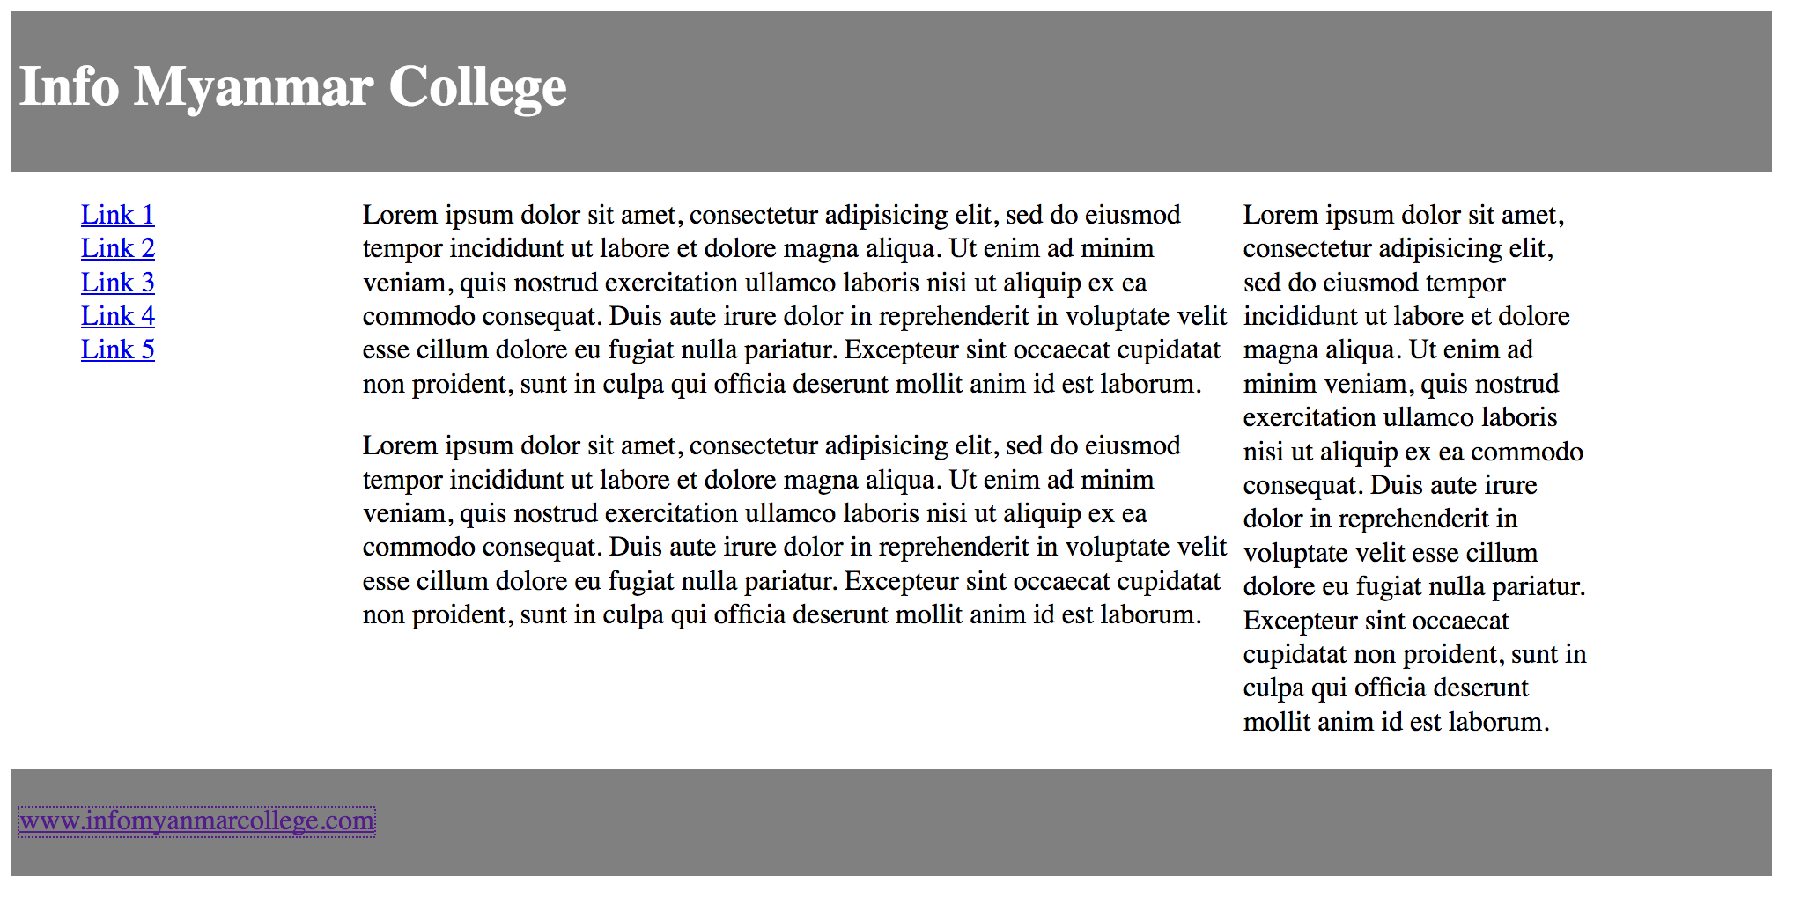

Exercise 1

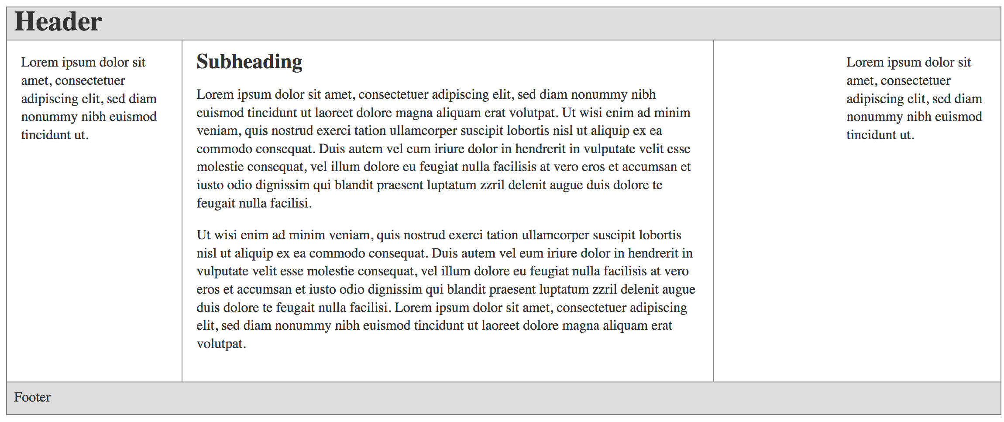

Sample Page 4 (Creating navigation)

samplePage4.html

|  |
| --- |
| <!DOCTYPE html>  <html>  <head>  <title></title>  <style type="text/css">  ul,li{  margin: 0px;  padding: 0px;  }  li{  background: red;  width: 150px;  margin-left: 10px;  float: left;  list-style: none;  height: 40px;  line-height: 40px;  text-align: center;  border: 10px outset red;  border-radius: 20px 0px 20px 0px;  }  li:hover{  background: green;  border: 10px outset green;  }  li a{  color: white;  text-decoration: none;  display: block;  }  </style>  </head>  <body>  <ul>  <li><a href="#">One</a></li>  <li><a href="#">Two</a></li>  <li><a href="#">Three</a></li>  <li><a href="#">Four</a></li>  <li><a href="#">Five</a></li>  </ul>  </body>  </html> |

Output



hover effect



Exercise

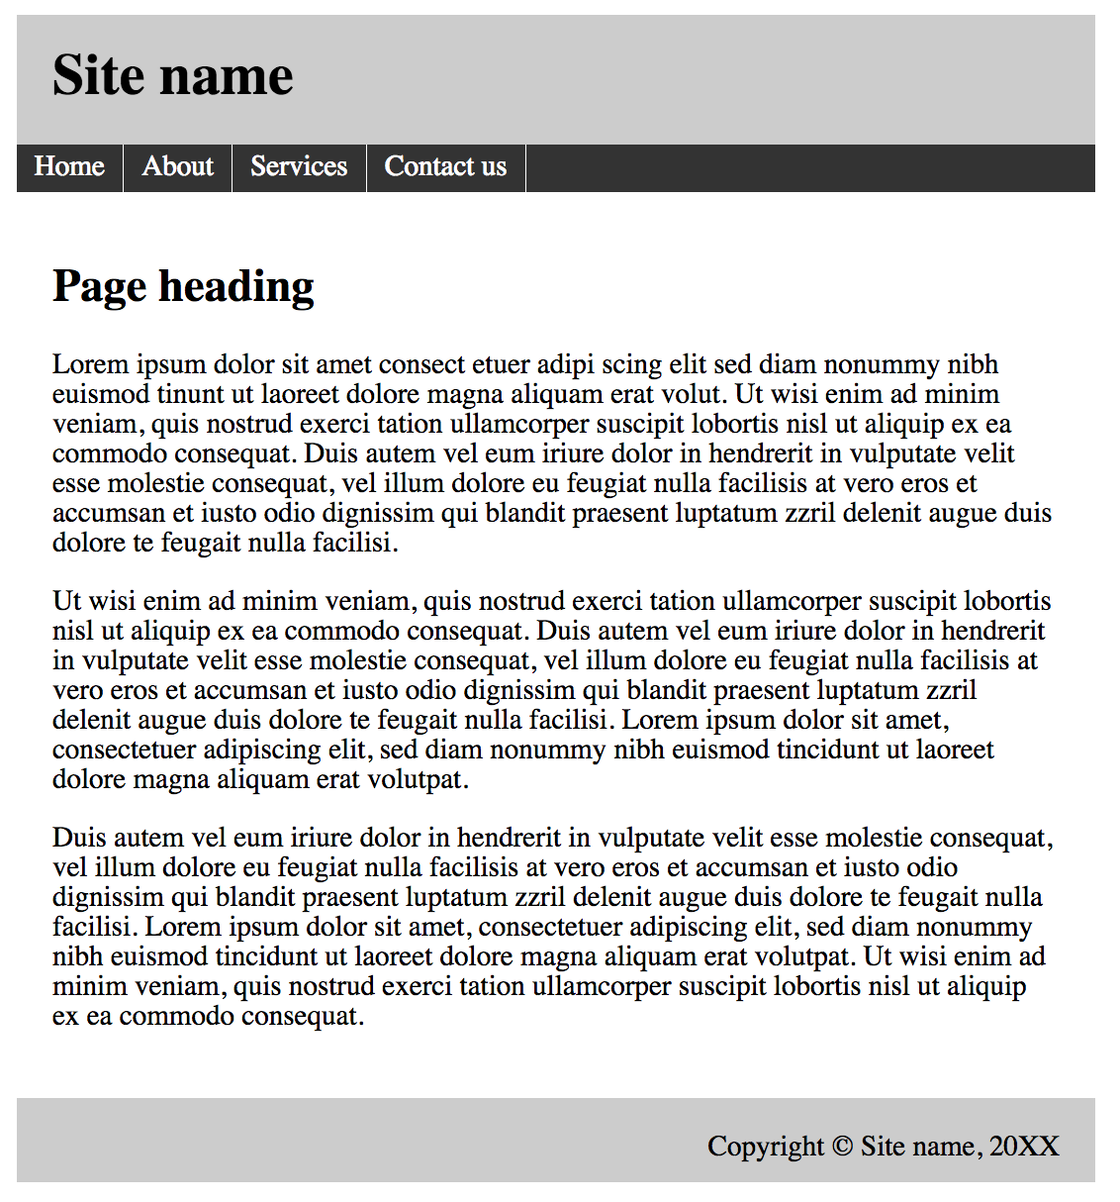

**Creating Sample Page**

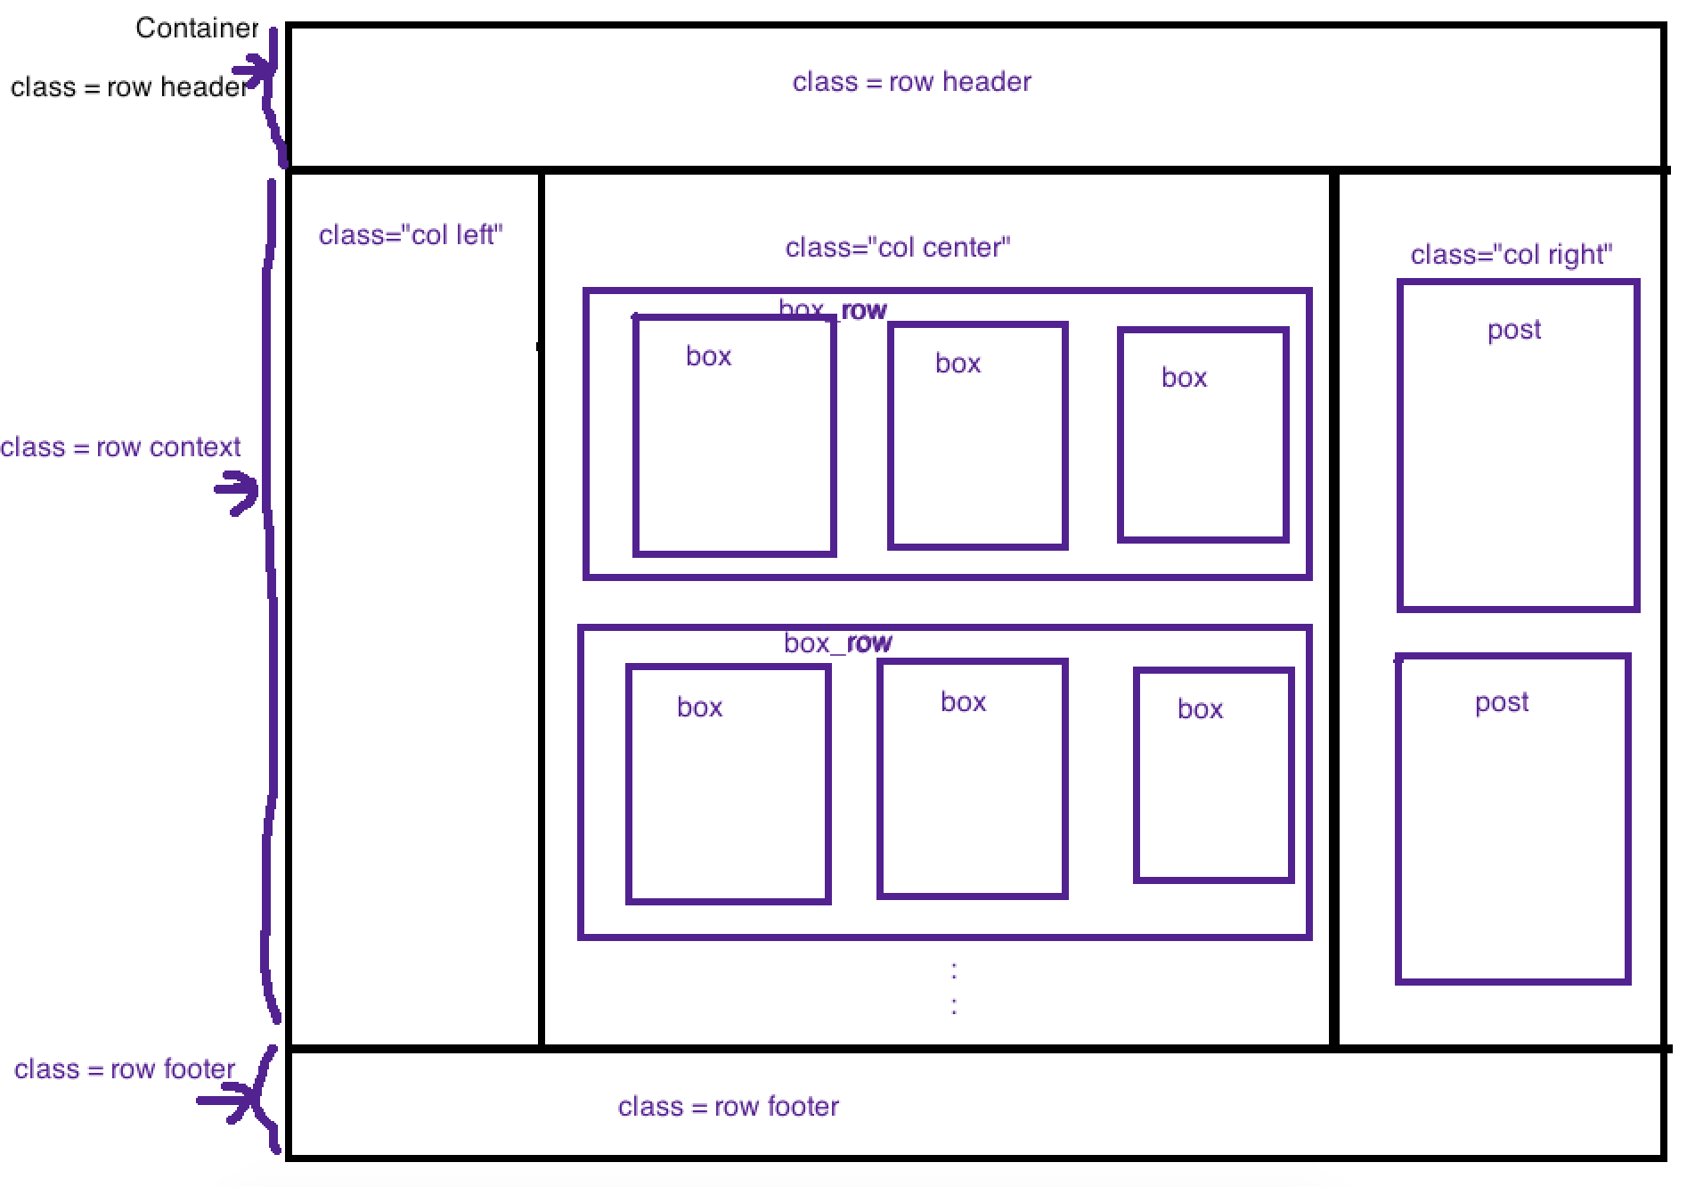

**Step One**

**Create index.html**

|  |
| --- |
| <!DOCTYPE html>  <html>  <head>  <title></title>  <link rel="stylesheet" type="text/css" href="style.css">  </head>  <body>  <div class="container">  <div class="row header"></div> <!-- header end-->  <div class="row context">  <div class="col left"></div>  <div class="col center">  <div class="box_row">  <div class="box"></div>  <div class="box"></div>  <div class="box"></div>  </div>  <div class="box_row">  <div class="box"></div>  <div class="box"></div>  <div class="box"></div>  </div>  <div class="box_row">  <div class="box"></div>  <div class="box"></div>  <div class="box"></div>  </div>  </div>  <div class="col right">  <div class="post"></div>  <div class="post"></div>  <div class="post"></div>  </div>  </div> <!-- context end -->  <div class="row footer"></div> <!-- footer end -->  </div>  </body>  </html> |

**Step 2**

**Create style.css**

|  |
| --- |
| body{  background: url(images/bg2.jpeg);  }  .container{  width: 1200px;  margin: 0 auto;  }  .header,.footer{  text-align: center;  border: 1px solid black;  height: 100px;  line-height: 100px;  clear: both;  }  .header{  }  .left{  width: 180px;    }  .center{  width: 790px;  }  .right{  width: 220px;  }  .footer{    }  .left,.center,.right{  float: left;  border: 1px solid black;  height: 950px;  }  .box_row{  height: 300px;  border: 1px solid black;  }  .box{  width: 230px;  height: 280px;  border: 1px solid black;  float: left;  margin: 15px;  }  .post{  border: 1px solid black;  height: 300px;  } |

**The out put will become**

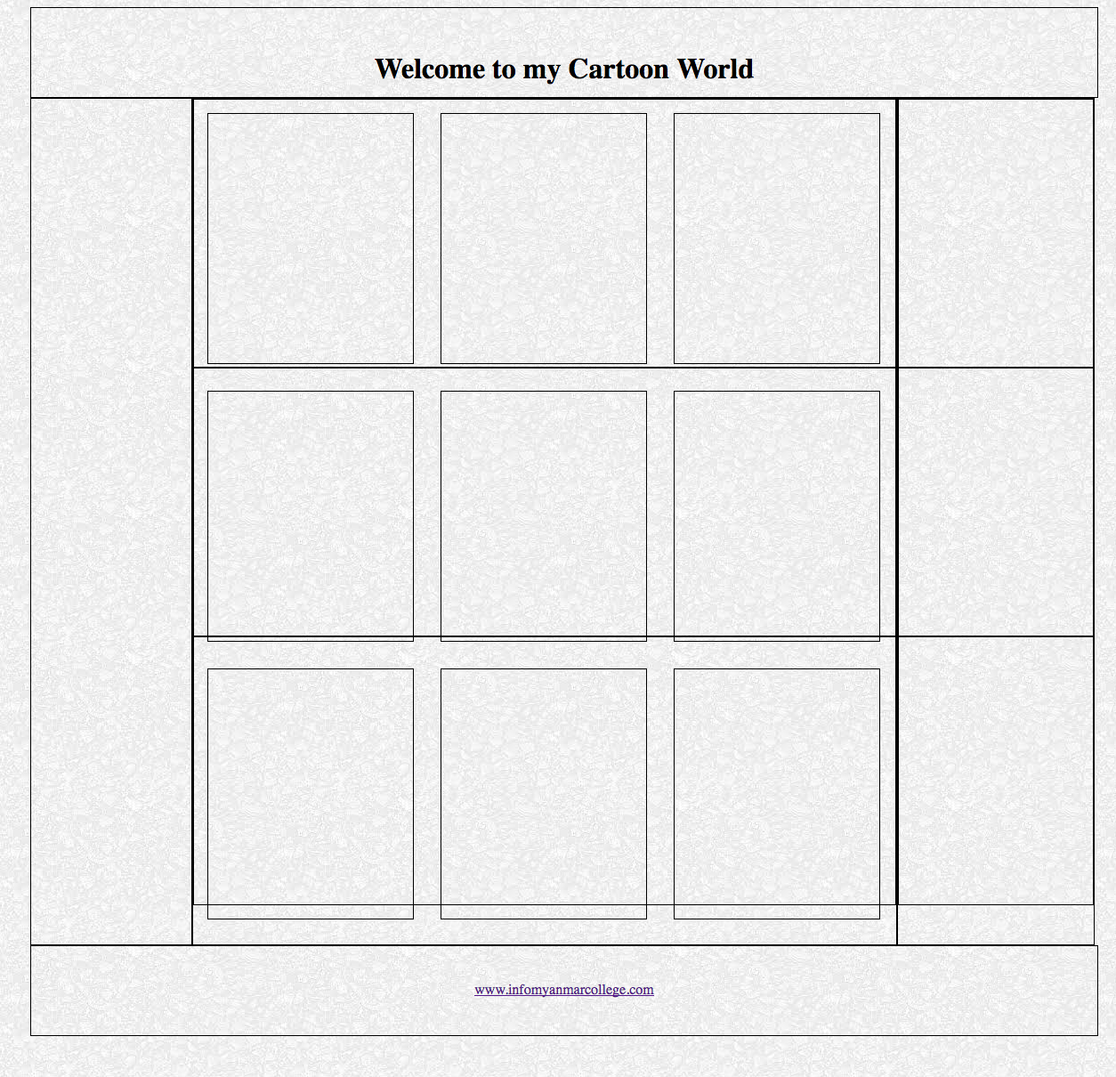

**Step 3**

**index.html**

|  |
| --- |
| <!DOCTYPE html>  <html>  <head>  <title></title>  <link rel="stylesheet" href="https://cdnjs.cloudflare.com/ajax/libs/font-awesome/4.6.3/css/font-awesome.min.css">  <link rel="stylesheet" type="text/css" href="style.css">  </head>  <body>  <div class="container">  <div class="row header">  <h1>Welcome to my Cartoon World</h1>  <p><img src="images/banner1.jpg"></p>  </div> <!-- header end-->  <div class="row context">  <div class="col left">  <ul>  <li><a href="#">Links</a></li>  <li><a href="#">Links</a></li>  <li><a href="#">Links</a></li>  <li><a href="#">Links</a></li>  <li><a href="#">Links</a></li>  <li><a href="#">Links</a></li>  <li><a href="#">Links</a></li>  <li><a href="#">Links</a></li>  <li><a href="#">Links</a></li>  <li><a href="#">Links</a></li>  </ul>  </div>  <div class="col center">  <div class="box_row">  <div class="box">  <img src="images/8.jpg">  </div>  <div class="box">  <img src="images/c1.jpg">  </div>  <div class="box">  <img src="images/c3.jpg">  </div>  </div>  <div class="box_row">  <div class="box">  <img src="images/c4.gif">  </div>  <div class="box">  <img src="images/c5.jpg">  </div>  <div class="box">  <img src="images/c7.jpg">  </div>  </div>  <div class="box_row">  <div class="box">  <img src="images/c8.jpg">  </div>  <div class="box">  <img src="images/c10.jpg">  </div>  <div class="box">  <img src="images/c12.gif">  </div>  </div>  </div>  <div class="col right">  <div class="post">  <h2 align="center">Post 1</h2>  <p> <i class="fa fa-angle-double-right" style="color:red"></i> <a href="#">Show latest posts </a></p>  <p> <i class="fa fa-angle-double-right" style="color:red"></i> <a href="#">Show latest posts </a></p>  <p> <i class="fa fa-angle-double-right" style="color:red"></i> <a href="#">Show latest posts </a></p>  <p> <i class="fa fa-angle-double-right" style="color:red"></i> <a href="#">Show latest posts </a></p>  <p> <i class="fa fa-angle-double-right" style="color:red"></i> <a href="#">Show latest posts </a></p>  <p> <i class="fa fa-angle-double-right" style="color:red"></i> <a href="#">Show latest posts </a></p>  <p> <i class="fa fa-angle-double-right" style="color:red"></i> <a href="#">Show latest posts </a></p>  <p> <i class="fa fa-angle-double-right" style="color:red"></i> <a href="#">Show latest posts </a></p>  <p> <i class="fa fa-angle-double-right" style="color:red"></i> <a href="#">Show latest posts </a></p>  </div>  <div class="post">  <h2 align="center">Post 1</h2>  <p> <i class="fa fa-angle-double-right" style="color:red"></i> <a href="#">Show latest posts </a></p>  <p> <i class="fa fa-angle-double-right" style="color:red"></i> <a href="#">Show latest posts </a></p>  <p> <i class="fa fa-angle-double-right" style="color:red"></i> <a href="#">Show latest posts </a></p>  <p> <i class="fa fa-angle-double-right" style="color:red"></i> <a href="#">Show latest posts </a></p>  <p> <i class="fa fa-angle-double-right" style="color:red"></i> <a href="#">Show latest posts </a></p>  <p> <i class="fa fa-angle-double-right" style="color:red"></i> <a href="#">Show latest posts </a></p>  <p> <i class="fa fa-angle-double-right" style="color:red"></i> <a href="#">Show latest posts </a></p>  <p> <i class="fa fa-angle-double-right" style="color:red"></i> <a href="#">Show latest posts </a></p>  <p> <i class="fa fa-angle-double-right" style="color:red"></i> <a href="#">Show latest posts </a></p>  </div>  <div class="post">  <h2 align="center">Post 1</h2>  <p> <i class="fa fa-angle-double-right" style="color:red"></i> <a href="#">Show latest posts </a></p>  <p> <i class="fa fa-angle-double-right" style="color:red"></i> <a href="#">Show latest posts </a></p>  <p> <i class="fa fa-angle-double-right" style="color:red"></i> <a href="#">Show latest posts </a></p>  <p> <i class="fa fa-angle-double-right" style="color:red"></i> <a href="#">Show latest posts </a></p>  <p> <i class="fa fa-angle-double-right" style="color:red"></i> <a href="#">Show latest posts </a></p>  <p> <i class="fa fa-angle-double-right" style="color:red"></i> <a href="#">Show latest posts </a></p>  <p> <i class="fa fa-angle-double-right" style="color:red"></i> <a href="#">Show latest posts </a></p>  <p> <i class="fa fa-angle-double-right" style="color:red"></i> <a href="#">Show latest posts </a></p>  <p> <i class="fa fa-angle-double-right" style="color:red"></i> <a href="#">Show latest posts </a></p>  </div>  </div>  </div> <!-- context end -->  <div class="row footer"><a href="http://www.infomyanmarcollege.com">www.infomyanmarcollege.com</a></div> <!-- footer end -->  </div>  </body>  </html> |

**style.css**

|  |
| --- |
| *{  margin: 0px;  padding: 0px;  }  body{  background: url(images/bg2.jpeg);  }  .container{  width: 1200px;  margin: 0 auto;  background: #DFDCE3;  box-shadow: 5px 5px 5px gray;  }  .header,.footer{  background: #FEFCED;  text-align: center;  clear: both;  }  .header{  padding-top: 50px;  }  .context{  padding-top: 30px;  }  .left{  width: 180px;    }  .left ul li{  list-style: none;  font-size: 18pt;  text-align: center;  margin: 15px;  height: 40px;  line-height: 40px;  border: 3px solid #D91BD7;  border-radius: 50px 0px 50px 0px;  background: #FEFCED;  box-shadow: 3px 3px 3px gray;  }  .left ul li:hover{  box-shadow: 8px 8px 8px gray;  }  .left ul li a{  text-decoration: none;  color: #7F0007;  display: block;  }  .center{  width: 790px;  }  .right{  width: 220px;  }  .footer{  height: 70px;  line-height: 70px;  }  .left,.center,.right{  float: left;  /*border: 1px solid black;*/  height: 950px;  }  .box_row{  height: 300px;  /*border: 1px solid black;*/  }  .box{  background: url(images/border2.png);  background-size: 100% 100%;  width: 230px;  height: 280px;  /*border: 1px solid black;*/  float: left;  margin: 15px;  text-align: center;  border-radius: 10px;  box-shadow: 5px 5px 5px gray;  }  .box:hover{  box-shadow: 0px 0px 0px gray;  }  .box img{  width: 85%;  height: 85%;  margin: 10px;  }  .post{  background: #FEFCED;  margin: 10px;  padding: 10px;  border-radius: 10px;  }  .post p a{  font-size: 12pt;  line-height: 1.5em;  text-decoration: none;  color: #CEB572;  }  .post h2{  /*background: #DC1DDA;*/  background: #970109;  color: white;  padding: 15px;  } |

**Output**

